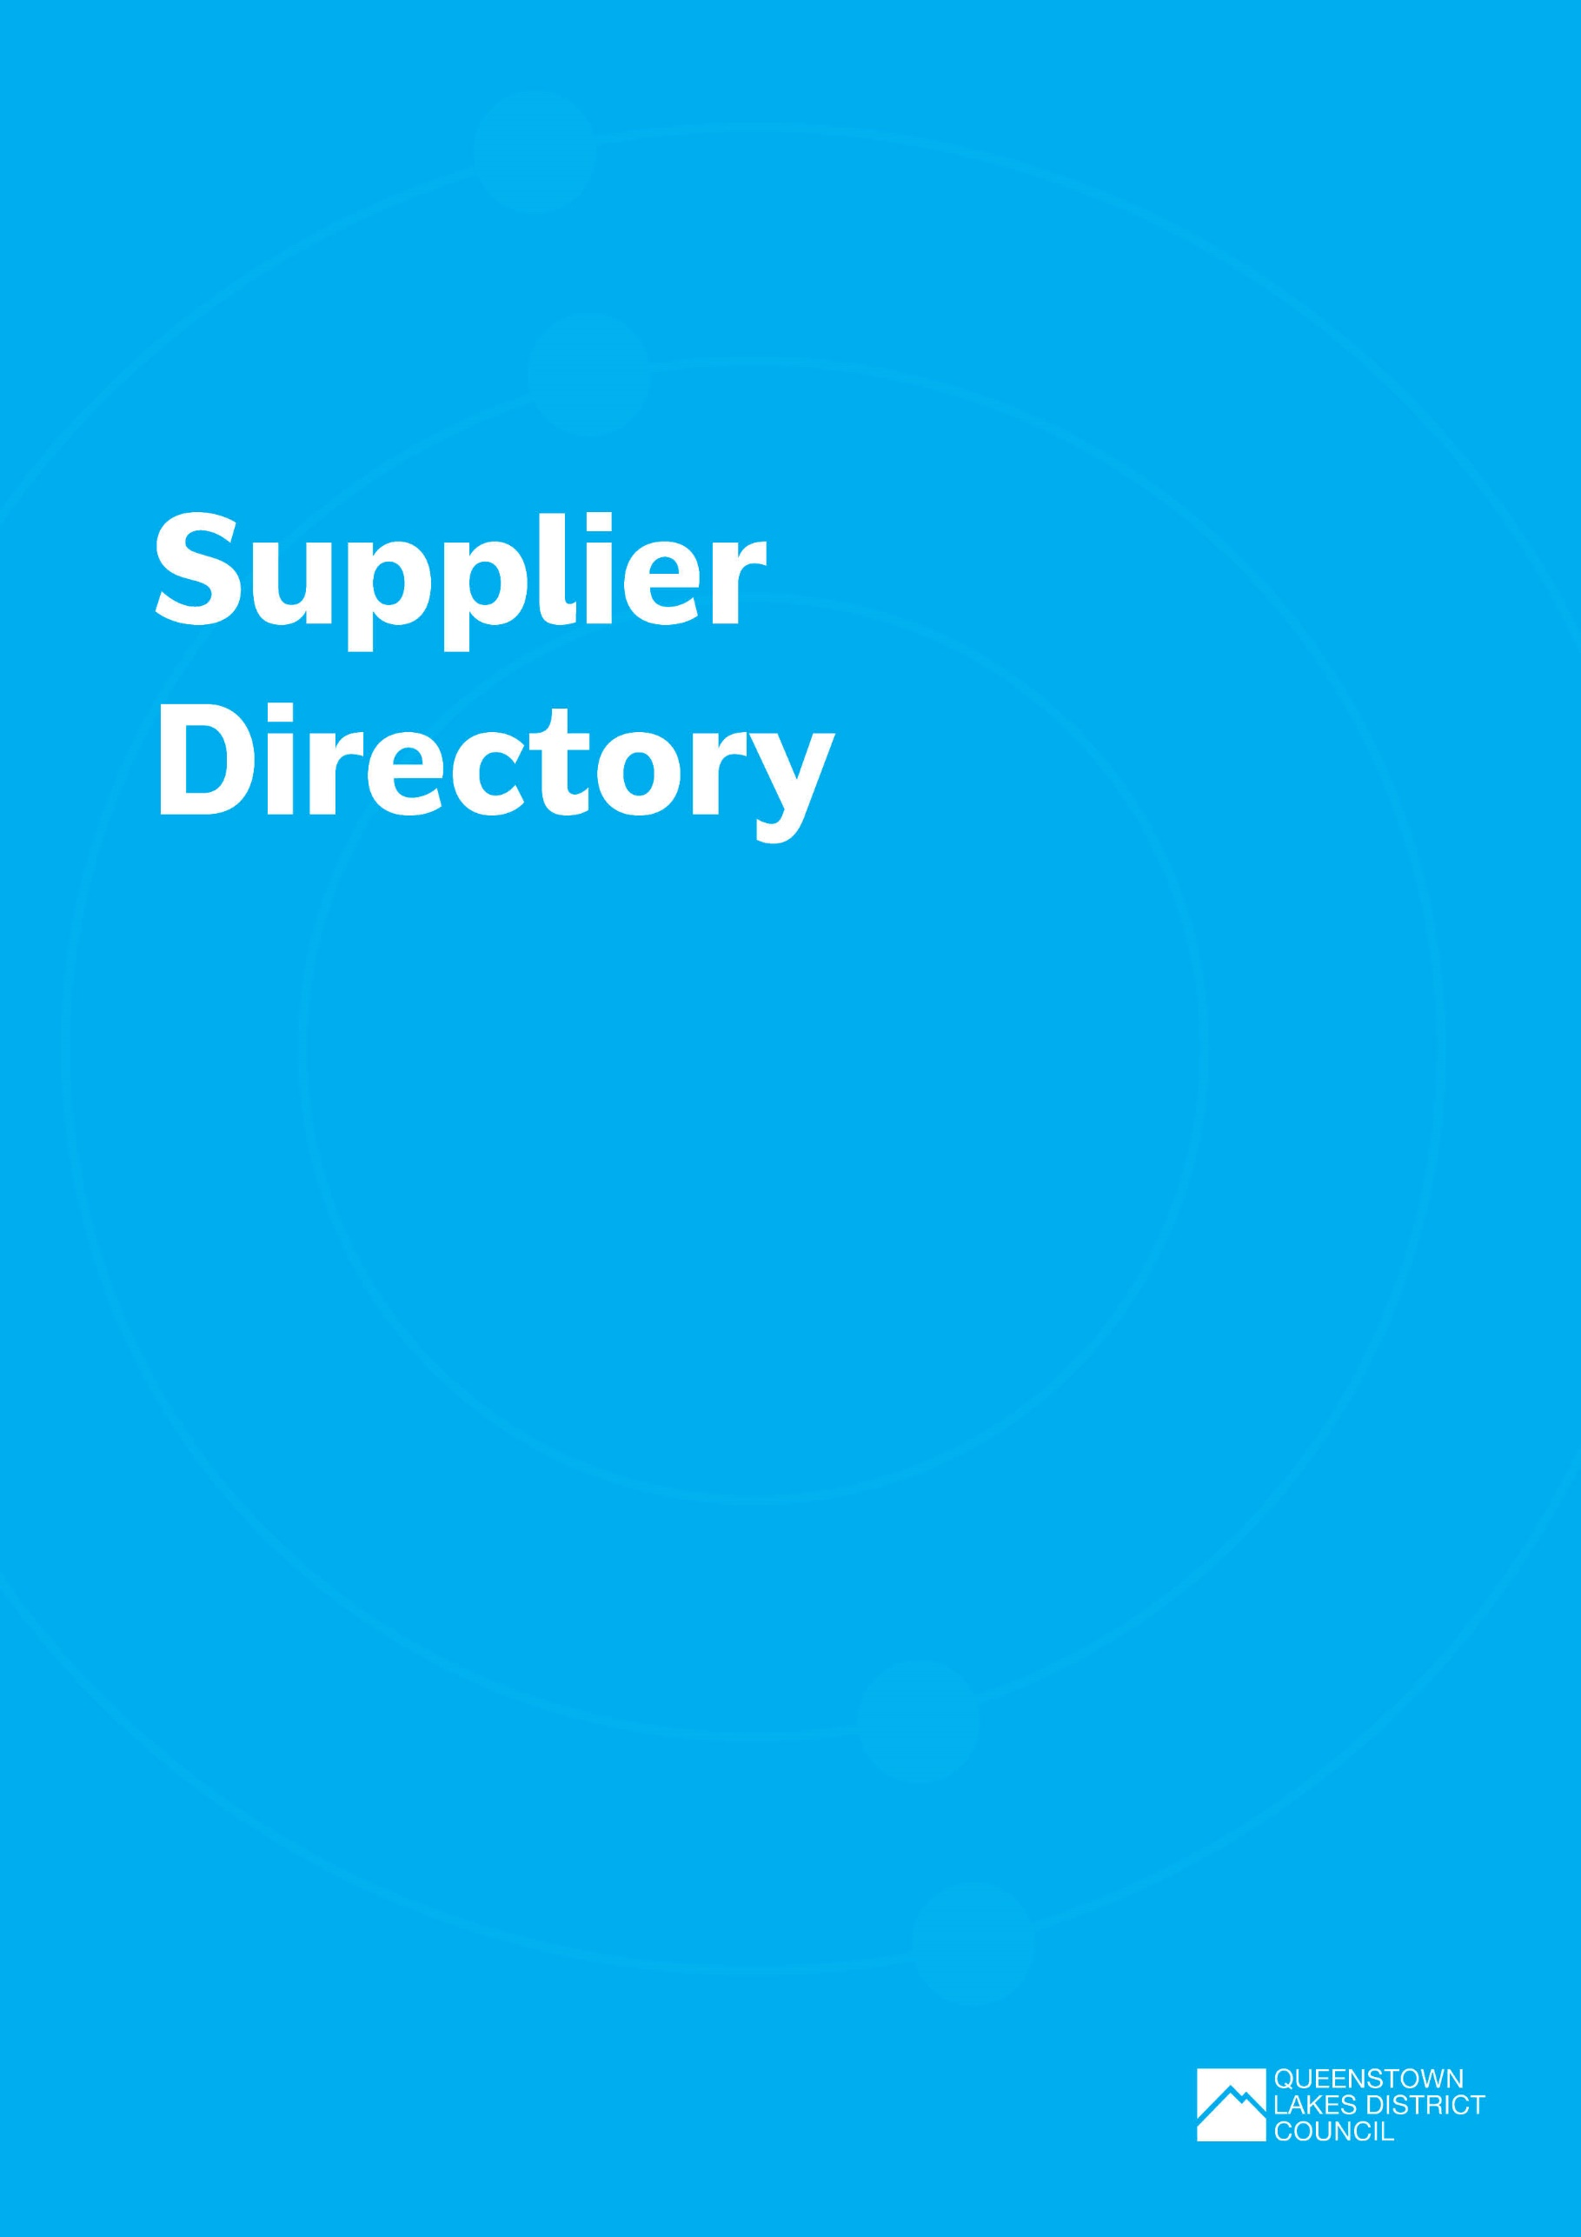

Supplier Directory

Service Provider | Service Provision | Contact details
COMMERCIAL WASTE AND RECYCLING SERVICE PROVIDERS/COLLECTORS
Wastebusters | - Event recycling services  - Reuse shop  - Reusable serveware hire for smaller events  - Waste minimisation advice  - Waste audits and reporting | Ballantyne Road, Wānaka  Tel. 03 443 8606  www.wastebusters.co.nz
AllWaste | - Bin and signage hire  - Rubbish and recycling collection  - Reporting | www.allwaste.co.nz  Wānaka 03 443 6063  Queenstown 03 441 3620
Waste Management | - Bin/skip hire  - Rubbish and recycling collection | www.wastemanagement.co.nz
Smart Environmental | - Bin/skip hire  - Rubbish and recycling collection | www.smartqueenstown.com  Tel. 0800 424990
Cookright Vat Man | - Cooking oil recycling | www.cookright.co.nz  Tel. 0800 828626
Flower Power (NZ) Ltd | - Used waste oil collection | www.flower-power.co.nz
LOCAL WASTE AND RECYCLING FACILITIES
Wakatipu Recycling Centre/ Materials Recovery Facility (MRF) | This is the district's current materials recovery facility where recycling is sorted and baled for market. It is a QLDC owned facility that is operated on behalf of council by their solid waste contractor. Materials accepted through the MRF include;  - Paper and cardboard (including pizza boxes free from grease and food)  - Aluminium and steel cans.  - Plastic bottles, trays, and containers marked with recycling symbols ♳, ♴ and ♷  - Glass bottle and jars – all colours | 112 Glenda Drive, Frankton, Queenstown  Tel. 03 341 2092  Recycling Centres | Queenstown Lakes District Council (qldc.govt.nz)
Frankton Transfer Station | - Accepts general waste and certain materials for diversion including:  - Green waste  - Tyres  - Scrap metal  - Electronic Waste including batteries  - Hazardous waste  - Gas cylinders  - Whiteware  - Car seats  Operated by Waste Management NZ on behalf of QLDC | 110 Glenda Drive, Frankton, Queenstown  Tel. 03 348 5126  Transfer Stations | Queenstown Lakes District Council (qldc.govt.nz)
Wānaka Transfer Station | - Accepts general waste and certain materials for diversion including:  - Green waste  - Tyres  - Scrap metal  - Electronic Waste including batteries  - Hazardous waste  - Gas cylinders  - Whiteware  - Car seats  Operated by Waste Management NZ on behalf of QLDC | Ballantyne Road, Wānaka  Tel. 03 348 6125  Transfer Stations | Queenstown Lakes District Council (qldc.govt.nz)
Wastebusters | - Recycling drop off  - Reuse shop | Ballantyne Road, Wānaka  Tel. 03 443 8606  www.wastebusters.co.nz
COMPOSTING
Wānaka Green Waste Landscaping & Supplies | - Accepts all types of greenwaste, from tree and hedge clippings to weeds and general garden waste | Ballantyne Road  Tel. 027 476 6034
Central Wormworx (Cromwell) | - Composting of food waste (accepts waste subject to prior arrangement) | Cromwell  T: 03 445 0263  http://www.centralwormworx.com
Grow Wānaka | - Community composting hub and community garden that accepts food scraps to build healthy soil and grow nutritious kai with the help of volunteers. No compostable packaging accepted | www.growWānaka.com
Zero Waste Glenorchy | - Community composting hub accepting food scraps including poultry, fish, small bones, eggs, dairy products, grains, cooked food, pasta, bread, vegetables, fruits (remove stickers), and paper (brown paper bags, coffee filters and grounds, paper towels and napkins). No compostable packaging accepted | www.glenorchycommunity.nz/community/organisations/zero-waste-glenorchy
Sharewaste | - A nationwide online platform which connects people who want to pass on their food scraps to local compost, worm, pig or chicken farmers | https://sharewaste.com
Dr Compost | - The Dr Compost programme can provide expert advice on a range of composting options | www.wastebusters.co.nz/dr-compost
Bokashi Bins | - Subsidised Bokashi bins for composting Can be purchased at council offices or Wastebusters | Rubbish & Recycling | Queenstown Lakes District Council (qldc.govt.nz)
FOOD RESCUE ORGANISATIONS
KiwiHarvest | - Redistributing surplus, edible food. Contact prior to event if you believe there may be surplus, edible food remaining | www.kiwiharvest.org.nz
REUSABLE INFRASTRUCTURE/EQUIPMENT HIRE
QLDC Hydration Station | - Mobile water trailer and portable drinking fountains available for hire | Queenstown Lakes District Council  T: 03 441 0499
Sustainable Queenstown’s DISHrupt | - Run by Sustainable Queenstown, DISHrupt is a great local initiative offering a selection of reusable metal crockery, cups and cutlery which can be hired for a small fee to help to rid events of disposable serveware. DISHrupting your event will not only reduce the amount of waste produced at the event but all donations will go back into making positive social and environmental impacts our community | www.sustainablequeenstown.org.nz/dishrupt
Turn Systems | - Turn Systems (formerly known as Globelet) will supply reusable cups that they collect and wash off-site which is great for large, multi-day events | https://turnus.in/
Party Plus | - Reusable infrastructure for hire including;  - Crockery, glassware, cutlery  - Furniture  - Marquees | www.partyplus.co.nz
Continental Event Hire | - Reusable infrastructure for hire including;  - Crockery, glassware, cutlery  - Furniture  - Linen  - Marquees | Contact Us | Continental Event Hire (hirepool.co.nz)
Plastic Free Wanaka | - Mug tree and mug library available for hire – suitable for smaller events | www.plasticfreewanaka.co.nz
Ripe | - Reusable infrastructure for hire including;  - 3 x 1000 litre water tanks  - Serveware (3000 enamel plates, knives, forks and spoons).  - 3 x sorting stations and signage | Otago Event Planning nathan@oep.nz
Cyclorama | - Glassware for hire | dave@cyclorama.co.nz
Remarkable Markets | - Reusable serveware for hire  - Hireable venue with wash station onsite | info@remarkablesmarket.com
Paper 4 Trees | - Produce reusable bin covers for purchase | Paper4trees.co.nz
Again Again | - Again Again is a technology platform that enables vendors to loan, track and assure returnable packaging | https://www.againagain.co/
SJ Allen | - Registered water carrier with a hireable water truck | www.sjallenholdings.co.nz  Tel. 0800 752 553
SPECIALIST EVENT WASTE MINIMISATION SERVICE PROVIDERS
Closed Loop | - Event waste and cleaning services including; bin hire, staffing, waste management, post-event waste reports | Sustainable Waste Management Services | Closed Loop
Wastebusters | - Provision of infrastructure like bins, event plans, recommended packaging for suppliers, diversion targets, waste audits, etc | Events Recycling - Wastebusters
Waste Watchers | - Event waste minimisation services including, provision of a recycling team, organisation of bins and signage, calculating diversion rates, working with vendors, educating the public and helping you meet local council requirements | Services | Waste Watchers Ltd
Clean Event | - Event waste minimisation services including, provision of a recycling team, organisation of bins and signage, calculating diversion rates, working with vendors, educating the public, etc | Clean Event - Event Waste Management Services Auckland
EMISSIONS ESTIMATION, VERIFICATION AND MITIGATION
Carbon and Energy Professionals | Carbon and energy professionals organisation | https://cep.org.nz/
Environmental Accounting Services (EAS) | Help clients understand how to estimate their GHG emissions, what they can do to reduce their environmental impact and how they can play their part in climate change mitigation globally | https://enviroaccounts.com/  Wānaka
Toitū Envirocare | Greenhouse gas emissions auditing, verification and certification programmes | https://www.toitu.co.nz/
TREE PLANTING AND COMMUNITY PROJECTS
Carbon Click | Climate action and carbon credits | https://www.carbonclick.com/
Climate Action Company | Helping companies compile and reduce their emissions as well as certify them net zero, climate positive or reducing their emissions using a low cost high integrity method instead of operating the exchange. We also supply local QLDC native forest carbon credits and biodiversity credits. Being locally based I am keen to work with more companies in the region so appreciate your help to update our details. | https://www.climateactionco.com  hello@climateactioncompany.com
EKOS | Connect organisations and governments with indigenous planting projects through carbon measurement and offsetting services | https://ekos.co.nz/
Glenorchy Community Native Plant Nursery | Native nursery and community planting organisation | https://givealittle.co.nz/cause/capturing-carbon-loving-our-landscapes  (Glenorchy)
Hinemoana Halo | Ocean and forest conservation projects | https://www.conservation.org/aotearoa/hinemoana-halo
Love Wānaka | Love Wānaka is a charitable funding platform that seeks to connect visitors – and the industry that supports them – to projects of value in the Wānaka region through funding and volunteer opportunities. | https://lovewanaka.co.nz/
Love Queenstown | Love Queenstown aims to drive impact at scale, by raising funds and awareness for local environmental action with all funds directly supporting charitable initiatives and organisations within the Queenstown region. | https://www.loveqt.co.nz/
Southern Lakes Sanctuary | Landscape scale conservation projects | http://southernlakessanctuary.org.nz/  (Queenstown Lakes)
Te Kākano Aotearoa Trust | Native nursery and community planting organisation | tekakano.org.nz  Wānaka)
Trees that Count | A platform that connects people and organisations to native tree planting projects across Aotearoa | https://treesthatcount.co.nz/
WAI Wānaka | Community catchment restoration group | https://waiWānaka.nz/
Whakatipu Reforestation Trust | Native nursery and community planting organisation | https://wrtqt.org.nz  (Queenstown)
Wānaka Community Workshop | A community workshop to make, share and repair items | www.Wānakacommunityworkshop.org.nz
TRANSPORT PROVIDERS
CoSeats NZ | Rideshare website | www.coseats.co.nz
GoBus | Transport provider | http://gobus.co.nz/
Orbus Queenstown | Transport provider (provides Queenstown’s public bus network) | Alta House  Level 1  Terrace Junction  1092 Frankton Road  Tel. 0800 672 8778
Queenstown Buses and Ferries | Transport provider | www.orc.govt.nz/public-transport/queenstown-buses-and-ferries
Ritchies Bus Services | Transport provider | www.ritchies.co.nz/charters
South Island Bus and Coach Hire | Transport provider | https://southislandbusandcoachhire.co.nz
Yello Taxis | Transport provider | https://yello.co.nz/

Additional Supporting Resources
Waste Resources
At events - Plastic Free July | Tips to reduce waste at events
Choosing a Safe and Sustainable Reusable Serviceware Fleet | A report commissioned by Takeaway Throwaways to support groups in Aotearoa New Zealand who are establishing reusable serveware systems to procure the most sustainable and safe reusable serveware fleets possible.
Let’s talk rubbish: the videos | beyond the bin | Beyond the Bins Practical Guide to Event Waste Minimisation. Resources include short guidance videos and free planning resources.
Library — Takeaway Throwaways | Reusable serveware systems and the policy changes needed to support their growth can be complex. Takeaway Throwaways is committed to creating and commissioning resources to help communities, businesses and policymakers to get best-practice reuse systems off the ground. This page is where you’ll find those resources.
Plastic Free Wanaka | Waste free shopping guide and SUCfree resources.
Reusable-serviceware-at-markets-December-2023.pdf (reuseaotearoa.org.nz) | Reusable serveware/packaging at markets (& events) in Aotearoa New Zealand information sheet.
Takeaway Throwaways | A campaign and resource library centred on reuse.
WasteMINZ zero waste events guidance | Guidance for creating signage for zero waste events.  Agreed colours for bins, bilingual signage, event signage and recycling bin suppliers.
WasteMINZ Compostable Guidelines | A series of guidelines for the use and advertising of compostable and biodegradable packaging.
Greener events guide – Ministry for the Environment | The Ministry for the Environment, in consultation with event organisers, key government departments and local authorities have a Greener Events Guide which contains practical ways to reduce the environmental impact of your event.
QLDC Zero Waste Top Tips Guide | A top tips guide with 5 easy steps to help reduce waste at events.
International Standard ISO 20121 – Sustainable Events | ISO 20121 offers guidance and best practice to help you manage your event and control its social, economic and environmental impact.
Carbon Resources
Climate Active Carbon Neutral Standard for Events (Australia) | Climate Active Carbon Neutral Standard for Events.
Measuring emissions: A guide for organisations: 2022 summary of emission factors | Ministry for the Environment | Organisations wishing to voluntarily measure and report greenhouse gas (GHG) emissions on an organisational basis for their New Zealand operations can use these GHG emission factors.

