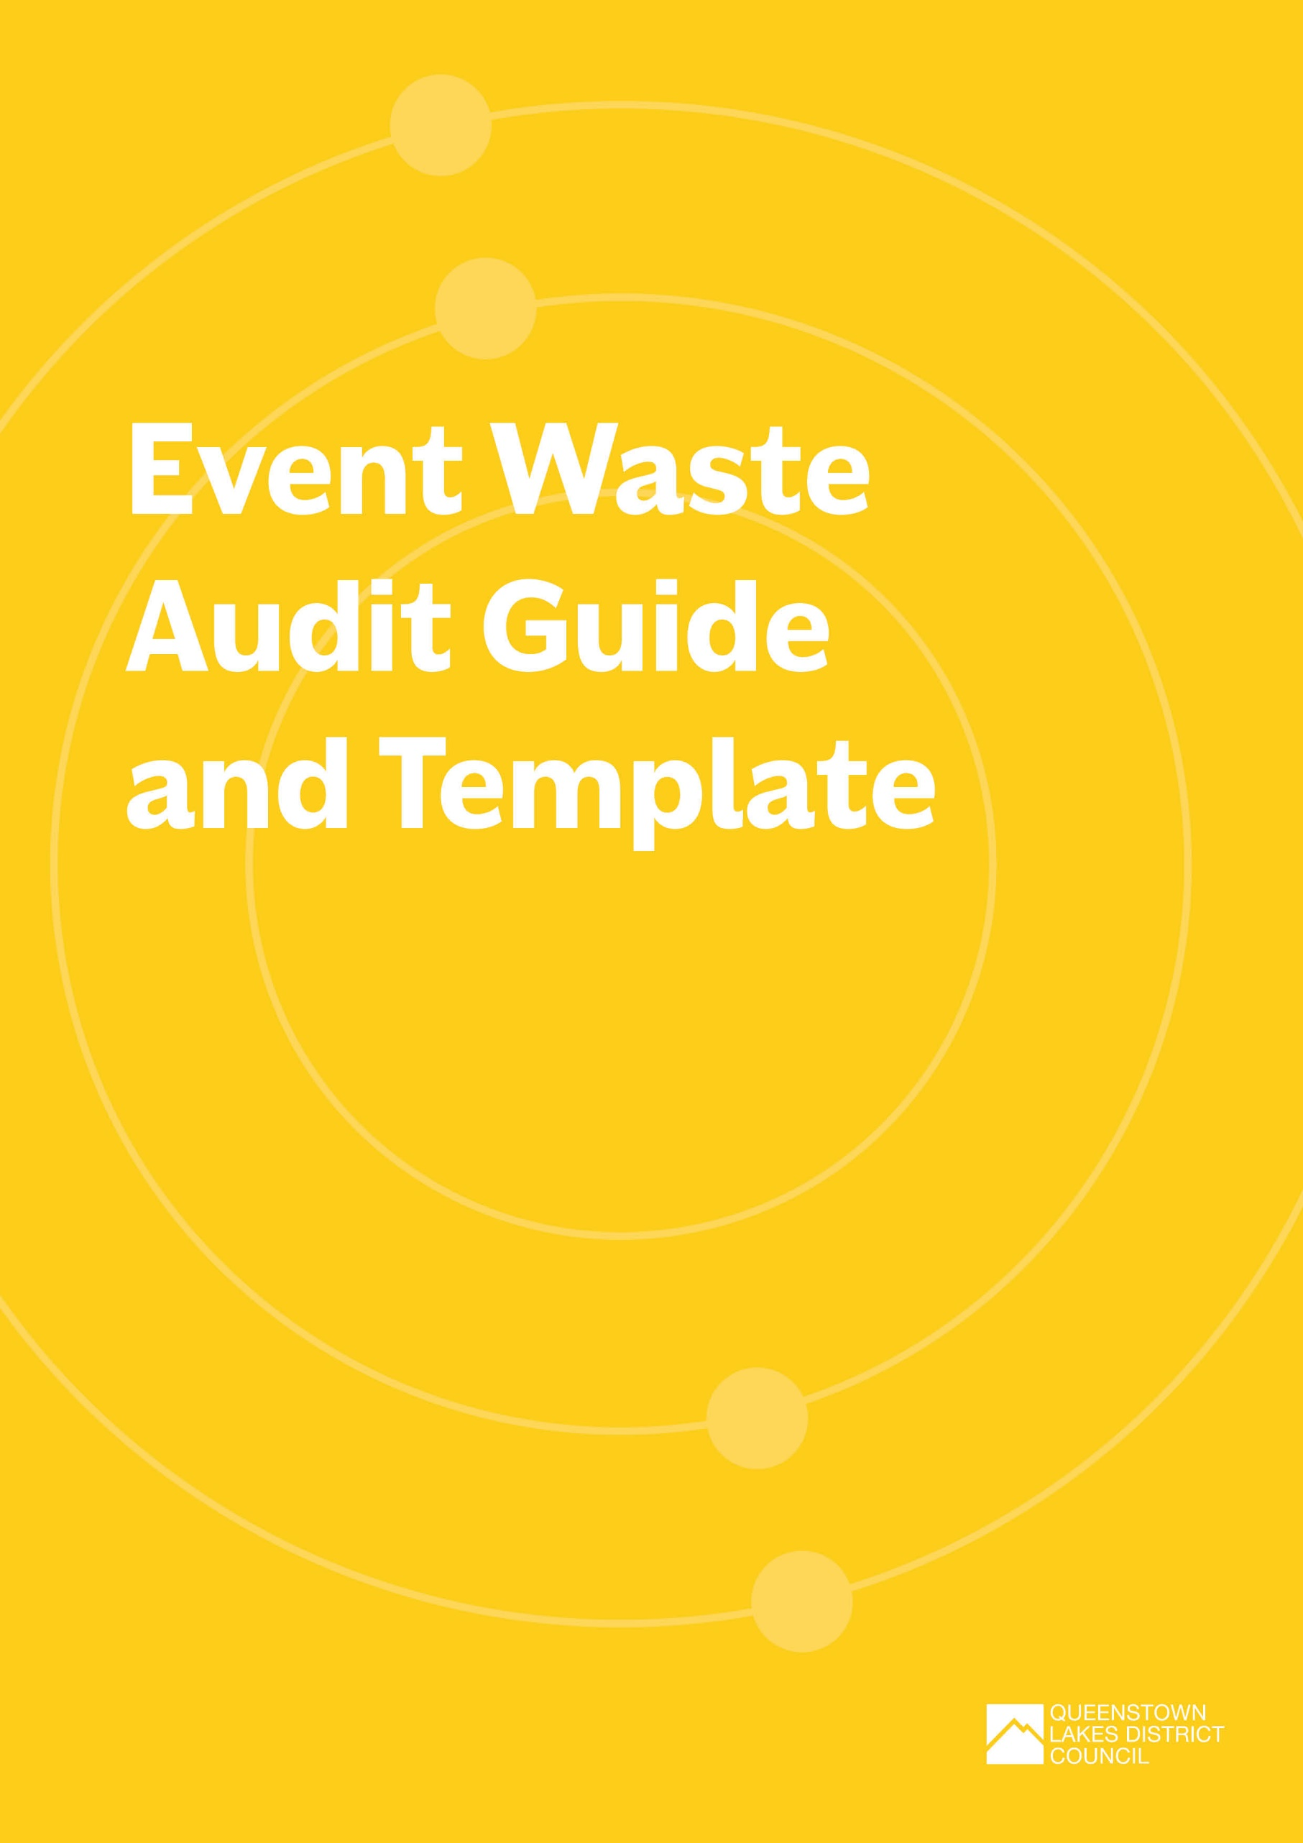

Event Waste Audit Guide and Template
After your event, it’s important to complete a waste audit to understand:
- how much waste of the different types you have collected at your event
- how much has or could have been diverted from landfill
- what your contamination rates are in your recycling or organics waste streams.
This data helps to measure your performance against the targets you’ve set. Make sure you communicate and celebrate your success!
If your event is small, or your waste collector can’t reliably provide you with the data you need, you can conduct a quick audit yourself.
Here's a summary of the key steps involved in conducting a waste audit:
Step 1 | Preparation | Gather necessary equipment – see list provided below.  Identify the areas within the event venue where waste audits will be conducted.
Step 2 | Define audit goals | Clearly define the goals and objectives of the waste audit, such as understanding the composition of waste, identifying opportunities for recycling, and assessing the effectiveness of waste reduction initiatives.
Step 3 | Develop a safe sorting method and a health and safety plan | Create a safe sorting method and health and safety plan for a waste audit to minimise risks and ensure the well-being of everyone involved.
Step 4 | Create sorting categories | Establish sorting categories based on the types of waste generated (e.g., mixed recycling, glass recycling, compost, landfill). Customise categories based on the specific waste streams relevant to the event.
Step 5 | Train your audit team | Train a team of volunteers or staff to assist with the waste audit. Ensure they understand the sorting categories and procedures for accurate data collection.
Step 6 | Collect waste samples | Collect samples of waste from selected areas, ensuring a representative cross-section. Use gloves and appropriate safety gear as needed.
Step 7 | Sort and weigh waste | Sort waste into the predetermined categories. Weigh each category separately to quantify the amounts of recyclables, compostables, and landfill-bound waste.
Step 8 | Record data | Record detailed data, including the weights and types of waste in each category. See example audit data collection sheet provided below.
Step 9 | Analyse results | Analyse the results to identify contamination and opportunities for waste reduction.
Step 10 | Identify improvement opportunities | Identify areas for improvement based on the audit results. Determine whether there are opportunities to reduce specific waste streams, increase recycling rates, or improve waste separation.
Step 11 | Communicate findings | Share the waste audit findings with stakeholders. Communicate the successes and areas for improvement to foster a culture of continuous improvement.

Waste Audit Equipment
Tarpaulin plus weights | This should be put down in the audit area to minimise mess from waste sorting. It can help to have some rocks or similar to weigh down the corners.
Sorting table | To reduce bending a table of appropriate height should be used.
Electronic scales (metric) | If the scales need to be plugged in, make sure you have a cord that can reach from your audit area.
Sorting containers | These are containers for sorting waste into different categories. Could be crates, plastic boxes or bins.
Waste sorting labels | Define what categories you want to sort waste/materials into and create labels for these to attach to your sorting containers.
Buckets (optional) | You may also want to use buckets that people can have right beside them to sort waste into before transferring it to the sorting container.
Bulldog clips, tape or bluetack | To attach labels to containers labels for sorting containers.
Weighing container | This is a box or bin that sits comfortably on your scales that can be used to weigh the materials. Use this same box or bin on the scales throughout the audit. Two identical containers can speed up the process. Or if all your sorting containers are identical, they can also double as the weighing containers.
Post-sorting bins | After materials have been sorted and weighed you will have materials that need to be stored away from the audit area before they are collected for processing.
Clipboards | Can be helpful for your data collection sheets.
Pens or pencils | It can be helpful to attach these to the clipboards.
Protective gear and first aid kit | Gloves for everyone handling waste (re-useable cut proof ones that can be washed are the best option), covered shoes, protective old clothing, hats & sunscreen if not working under cover.
Cleaning gear | A dustpan and brush is really useful for sweeping little bits of waste off your tarpaulin. You might also use a broom and rags or cloths. Detergent and scrubbing brush to wash out containers.

Waste Audit Data Collection Sheet Template
This is an example Waste Audit Data Collection Sheet that can be used for a basic audit of your event waste. Complete a new sheet for each waste/material stream you are auditing.
Waste Audit Data Collection Sheet
DATE:
UNIT OF MEASURE (WEIGHT OR VOLUME):
WASTE/MATERIAL STREAM: |  |  |  | E.g., General Waste, Mixed Recycling, Glass Recycling, Organics
Primary Category | Secondary Category | Weight/ Volume | Weight/Volume |  | Weight/Volume | Weight/Volume | Weight/Volume | Total Weight/ Volume
Materials that could have been diverted from landfill
Paper | Recyclable paper – office paper, newspaper, magazines, printed materials
Cardboard | Cardboard – clean cardboard boxes etc.
Plastics | Recyclable plastics - clean plastic bottles, trays and containers marked ♳, ♴ and ♷
Metals | Steel and aluminium cans
Glass | All glass bottles and jars that once contained food or beverages
Organics | Food scraps
Materials that cannot be diverted from landfill
All other general waste
Comments |  | Include notes on common items found as contamination or noted as opportunities for improvement e.g. coffee cups.
Note:
If scales are not available, you can make a rough assessment based on the volume of your sorting container. For example, the standard volume of a large wheelie bin is 240 litres – therefore, a full wheelie bin equates to 240 litres of rubbish (or compostables, or recyclables), a half-full wheelie bin is 120 litres etc. You will get a different result if you use volumes rather than weight to conduct your audit, as recyclables such as plastic bottles and cans tend to be light but bulky, whereas compostable and landfill waste tends to be heavier and more compact. Weight is the more reliable measure.
Contamination means that something has ended up in the wrong bin (e.g., aluminium cans in the glass stream or food scraps in the in the mixed recycling stream). Too much contamination of a waste stream can impact the ability to recycle or compost material.

