Glenorchy Airstrip Consultative Governance Committee Notice of Meeting
Date: Tuesday 4th June 2024
Time: 12:00 pm – 1:00 pm
Location: Church Street Meeting Room/ MS Teams

Attendees:
NAME
Juliet Breen (QAC) | Jeannie Galavazi (QLDC) | Quintin Howard (QLDC) | Priscila Da Silva (QLDC) | Christina Lister (GCA)
Niki Gladding (Councillor) | Josh Greer (Wyuna Preserve Residents Association) | Tom Butler (Blanket Bay) | Roger Davidson (QLDC)

Apologies: James Stokes (Operator), Nick Nicholson (Operator)
Agenda: #15
Item | Topic | Meeting Minutes
1. | Welcome | - Jeannie introduced Juliet Breen as the new QAC representative, replacing Jamie Waaka.  - Tom introduced Josh Greer as the new Wyuna representative, replacing Peter Campbell.
2. | Previous Minutes | - It was highlighted that the last meeting minutes were more of an open discussion than a decision-making exercise due to the nature of the analysis of the presented graphs for the survey responses.  - Niki has asked what costs would be involved in the operating fees.  - Jeannie has advised that the costs recovered go towards the maintenance of the airstrip, such as but not limited to the monitoring system and maintenance of the airstrip.  - Niki also would like to highlight the importance of the cost breakdown for policy change in the case of growth for the airstrip.  - Quintin has noted that there are limitations for growth due to the cap on the number of movements allowed on the airstrip because of the noise.
3. | QLDC update:  - 2024 Concessions  - GACGC to create a motion to support (or not) operator-requested landings | - QLDC has been directly in contact with the operators, approaching the number of landings they were requiring for the 2024 Concession agreement.  - This has been presented to the GACGC to understand whether they support the below numbers.  - ACTION: The participants of the GACGC initially agreed with the presented number. However, this was pending full approval, as all members would like the requested number to be run by the GCA. Christina will then come back with the CGA direction/instruction. This has been moved to be completed via email. The committee members supported this in principle during the meeting and formalised it via email—moved by Niki and seconded by Tom.  Year Operator Name Trading Name Requested landings 2024 Actual 2023  2024 Action Helicopters (HeliGY) Action Helicopters 900 742  2024 NZONE (Skydive Queenstown) Skydive Queenstown 12 4  2024 Glenorchy Air Ltd Glenorchy Air 80 34  2024 The Alpine Group Ltd Alpine Group 40 13  2024 The Helicopter Line The Helicopter Line 60 33  2024 Helicopters Qtn Ltd (Glacier Southern Lakes) Glacier Southern Lakes 40 21  2024 Tourism Milford Limited Ultimate Hikes 12 5  2024 Te Anau Helicopter Services Limited Milford Helicopters 40 5  1184 857  - Roger has explained that some points were raised during the communication process with the operators.  - Glenorchy Air was concerned about running out of landing numbers granted.  - Jeannie has advised that those issued were raised in the 2023 processing of the concession agreement. Therefore, the special approval process has been created and added to the QLDC website.  - Tom has asked how many applications QLDC has received for adding extra landing numbers by operators.  - Jeannie has advised that we have not received any request for additional landing, and most operators did not reach the agreed number under the concession agreement.  - Tom requested clarification regarding the landing fee payment for the operator under the concession agreement.  - Jeannie clarified that once the concession agreement is in place, most operators would pay an upfront fee for the number of landings that they have agreed upon.  - Roger has also noted that some operators would like to be charged monthly instead of a one-off charge for the year.  - Jeannie has queried the possibility of the concession agreement being granted for more than 12 months (2 yearly)  - Quintin advised that QLDC would like to retain the ability to grant the number of landings. Therefore, it could prove difficult to grant two-year concessions without adding conditions, such as if the allocated landings are not used to their totality, the remaining will be added back to the general pool, and the numbers granted for the next concession will be reduced. If we are able to manage the process closely, this should resolve the issue of having a concession granted for more than 12 months.  - Roger has proposed that we contact the operator prior to the next GYCGC meeting so that by February each year, we have all the concession agreements completed and ready for the year.  - Tom recommended moving the date to early December to contact operators, as this will be easier for them since the summer months are their peak season.  - During the meeting, it was added by QLDC that the landings are monitored monthly when all reports and invoices are completed.
ITEM 4: | Glenorchy – AIMMS Computer  - The AIMM PC located in the library is connected to the AIMM central server via the 4G cell phone network. The 4G modem sits on top of the PC under a desk in the public section of the library (see photo attached). This cell phone network is not as reliable for Glenorchy as a broadband connection, but this is not available in the Library due to QLDC-identified security risks. If the network goes offline, the is no loss of data as it catches up when it reconnects. However, power outages or the power to the PC is accidentally being turned off, will result in a loss of data. With the Library operating for 2 hours, 2 days a week, no personnel may be on-site for long periods to restart the PC. | - AIMM have enquired if a more “secure” location with a broadband connection is available in Glenorchy, ideally within 1.5km from the airfield.  (photo below)  AIMM System – under the library desk in Yellow:  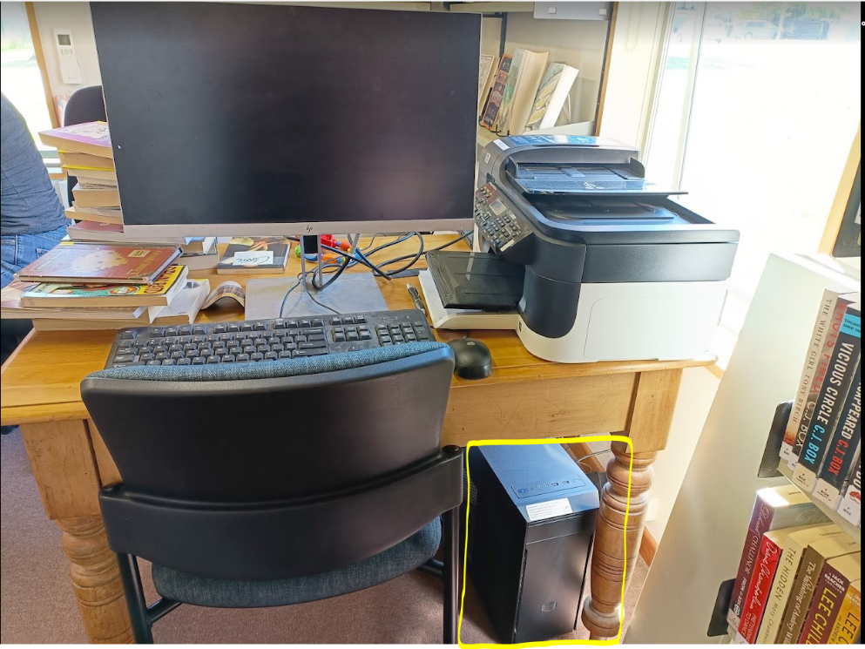  - Tom has advised that Blanket Bay does have the capacity to take over the system as they qualify for all requirements set by the AIMM System operators.  - The AIMM computer would be installed safely in their server room, where it would have direct internet cable connectivity. They also have a battery backup generator in case of power loss, as they do for all their internal computers.  - Priscila has advised that since we circulated the agenda, the AIMM Operators have informed QLDC that they will be sending us new Hardware/computer.  - ACTION: Roger will contact Tom to explore the option of moving the system to Blanket Bay.
5. | Reserve Management Plan Review Update  - Jeannie to present a detailed analysis of the Survey  - Key emerging themes for policy drafting  - Vision | - Jeannie presented a further detailed breakdown of the survey analysis. This is for a better understanding of the Glenorchy Aerodrome's future and to assist with the draft of the new policy.  Taking into consideration the positive and negative feedback that the survey has provided. There was a suggestion for an increase in the overall response graphs. However, most of those responses were from operators or people who did not reside in Glenorchy.  It was also noted that the Glenorchy residents would like the Aerodrome activities to stay where they are without any increase. The survey also reviewed what type of activities are supported. During the meeting, there was unanimous consent to support the residents' opinion when speaking about growth, as they are the most affected party, meaning their vote should have more impact than the other survey responses.  - ACTION: Jeannie will draft the vision and circulate it to the GACGC to gather the committee's thoughts prior to presenting it at the council meeting. This will also provide an opportunity for Wyuna and CGA to comment. It has also been moved to be presented via email.
6. | Complaints (QAC/QLDC) | - There have been no complaints to be presented.
7. | Airstrip Operations Update (QAC) | - Juliet took over explaining item 7, as Quintin had to leave for a different meeting and the GACGC went over the time.  - Juliet has completed the last runway/field inspections, and they have some remediation works underway on the marker boards on the lakeside of the strip. There have been no real issues with the strip. However, during communication with some operators, they have advised that the airstrip ground is rough and there is also a patch on the Glenorchy Township side.  Some improvements in the surface are needed for some of the operators to use the strip.  She has also noted that this would be a re-seeding kind of project.  - ACTION: Jennie has advised that she is not aware of who the actual maintenance of the land would fall under as this is beyond the maintenance agreed with QAC. She is going to check and advise. She also queried Juliet about the implications of the non-completion of this work during the current financial year. Jeannie will discuss the above with Quintin and Roger. The outcome is to be presented to the GACGC committee.  - Juliet has also requested, if possible, to have an estimation on the time frame for the maintenance of the ground surface, as this will impact operations, and she will need to notify operators of the rough areas as hazards for safety purposes.
8. | General Business | - No general business to discuss.

