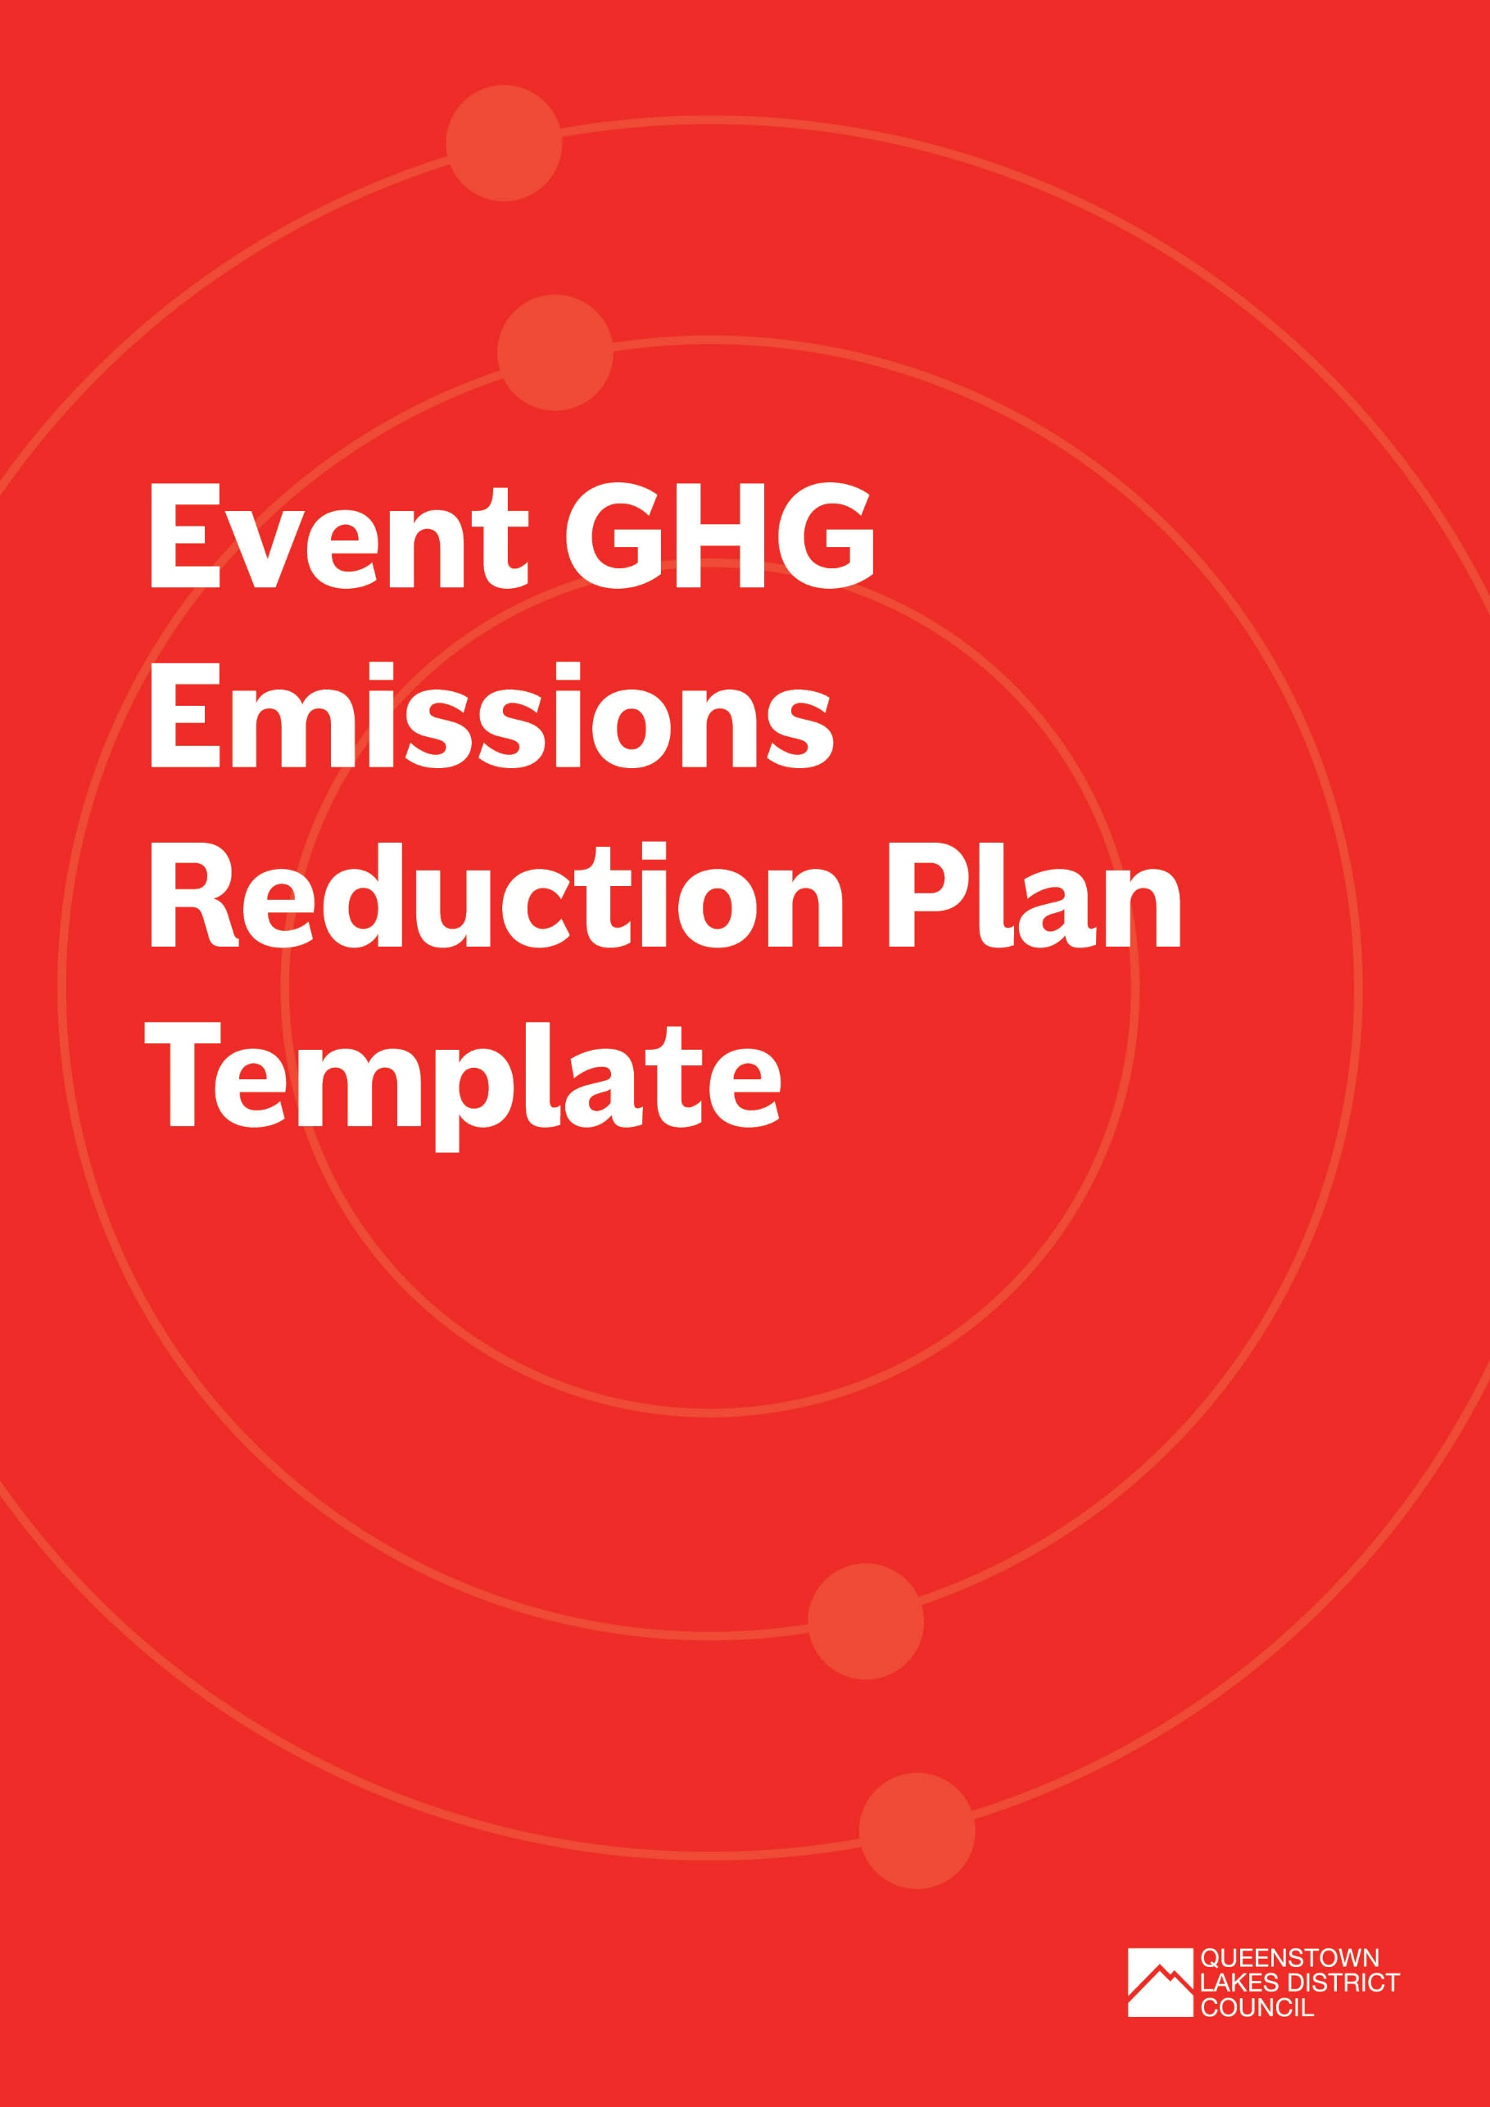

Event Greenhouse Gase (GHG) Emissions Reduction Plan Template
Use this template to outline your GHG Emissions Reduction initiatives and help set objectives and targets for reducing your event’s GHG emissions.
Before you start, make sure you read through the Event Waste and Emissions Reduction Guide and the supporting document on How to Estimate Event GHG Emissions which will help you estimate your event’s GHG emissions to understand your key emission sources.
The template is broken into the following sections:
- Event overview – if you have completed the Event Waste Minimisation and Management template, you can use the same details here
- Identifying your key GHG emission sources, or plans to collect emission data
- Detail of emissions reduction initiatives
- Emissions reduction objectives, targets, success indicators and supporting initiatives

How to use this template:
Complete each section below. You can add or remove rows in the tables as needed. We’ve provided some examples which you can delete as you work through your plan.

Event Overview
EVENT DETAILS
Event title: |  | Title of event/ official name of the event that will be referred to on any applications
Type of event: |  | E.g.:  - Arts / Cultural (Outdoor Exhibition or Performances)  - Entertainment (Music Festival, Circus, Concert)  - Community Event (School Fair / Gala Day, Fundraiser)  - Sports (Marathon, Cycle Race, Water Sports)  - Market (Craft Market, Food Market, Farmers Market)
Location (attach or insert map if possible): |  | Venue name, location and description
Date(s) of event: |  | Pack in:
 |  | Event start:
 |  | Event finish:
 |  | Pack out:
Time of live event: |  | Start time:
 |  | Finish time:
Estimated number of attendees:
Name of organisation delivering the event:
Event activities:
Number of food and beverage vendors:
Number of marketplace/ merchandise vendors:
CONTACT DETAILS
Name:
Organisation:
Role:
Phone number:
Email Address:

Estimate your Emissions
Things to consider | Provide details
Is this the first year for your event? | ☐ | Yes
 | ☐ | No
Have you estimated your event’s GHG footprint? Please select which option best applies. | ☐ | Yes. We have estimated the GHG footprint based on previous year’s data. Our three largest emission sources will be:
 | ☐ | Yes. We have estimated the GHG footprint based on a similar event. Our three largest emission sources will be:
 | ☐ | No. But we have a plan to collect data on (please list):
 | ☐ | No. We do not plan to collect data for this event (please state why).

Emission Reduction Initiatives
Identify what GHG emissions reduction initiatives you have selected for your event. Review the GHG Emissions Reduction checklist on page 36 of the Event Waste and Emissions Reduction Guide and include any other initiatives you have identified.
Initiative | Detail of what’s proposed | Who will be implementing?
Example: Provide on-site bike parking to encourage cycling | Example: A secure bike parking area will be set up at the centre of the event. Security will be ensured by giving cyclists a unique reference number to identify their bike, which will be parked in a fenced, staffed area. | - Staff to monitor secure bike parking area between gate opening and closing times
Example: Estimate attendee travel GHG emissions to incorporate 100% offset of these emissions in the ticket price. | Example: From previous year’s “How did you get here?” survey, estimate attendee travel GHG emissions. Include cost of purchasing 100% offset of emissions in this year’s ticket price.  The Communications Plan will promote our emissions reduction objectives and targets and explain why we’ve opted to include offsets in the ticket price. | - Sustainability manager to estimate attendee travel GHG emissions from last year’s survey and calculate offset purchase cost to incorporate into ticket price.  - Purchase offsets through organisation which ensure they meet international best practice such as additionality and permanence requirements.

Emissions objectives, targets and success indicators
Based on your GHG footprint, list the objectives and targets you have identified to reduce GHG emissions and/or improve data collection for your event. Identify how you will measure success and what initiatives you will implement to achieve your objectives and targets (add extra lines to the table if needed).
OBJECTIVES | TARGET | HOW WILL YOU MEASURE SUCCESS? | INDICATORS FOR SUCCESS | SUPPORTING INITIATIVES
Example: To reduce transport emissions from event attendees | Example: 75% of attendees arrive on foot, on bike, or by bus | Example: Survey sample of attendees at the gate to ask where they travelled from and how they travelled | Example: Less than 25% of attendees arrived by car | Communications and Engagement Plan to promote active travel and bus options

Sharing your message
Share your GHG emission reduction goals, objectives, targets and initiatives with your stakeholders including suppliers, vendors and event attendees. Make sure you communicate how they can help you achieve these. A Communication Plan will help you formalise how you share your message with stakeholders.
Have you developed a Communication Plan to help raise awareness of your GHG emission reduction initiatives? You can use the Communication and Engagement Plan Template as a guide. | ☐ | Yes
 | ☐ | No

Tracking Success
How will you track the success of your GHG emission reduction initiatives? What will you be measuring or recording? Refer How to Estimate Event Greenhouse Gas Emissions for more information.

NEED FURTHER SUPPORT?
For further information or assistance with your GHG Emissions Reduction Plan, please contact the Queenstown Lakes District Council at climateaction@qldc.govt.nz

