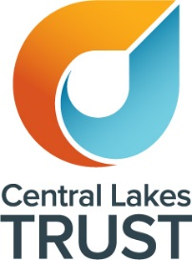

CENTRAL LAKES ARTS SUPPORT SCHEME (CLASS)

IN ASSOCIATION WITH YOUR LOCAL COMMUNITY ARTS COUNCIL

Guidelines -July 2024 – June 2027

Central Lakes Trust is a charitable trust supporting our community, by granting funds for charitable purposes throughout the Central Lakes district.

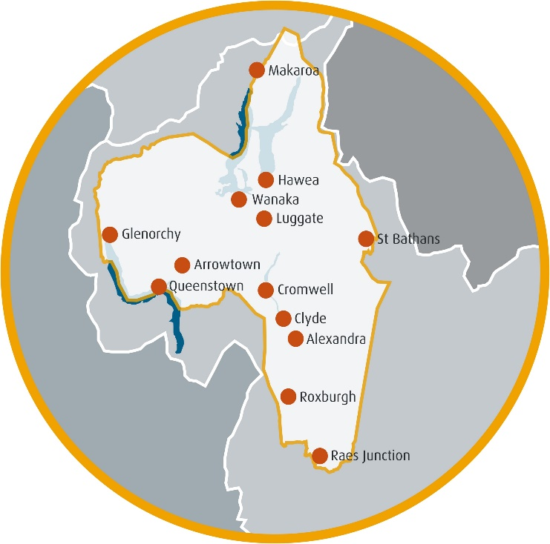

Annually, approximately $10 million is granted to community organisations throughout the Trust's funding region, which spans most of Central Otago and Southern Lakes.

Central Lakes Trust supports arts in the community both directly and through the CLASS scheme.

CLASS has been set up to assist groups and organisations at the “grassroots” level.

****Central Lakes Art Support Scheme****

**The purpose of the Central Lakes Arts Support Scheme, known as CLASS, is to increase participation in the arts, and the range and diversity of arts available to the community.**

**The maximum amount that can be funded through this scheme is $2,500 per organisation/group per annum.**

**Please note: If funding greater than $2,500 is required, and your organisation is registered with Charities Services please go to** <https://www.clt.net.nz/how-we-fund> **to read more about grant eligibility and then contact the Central Lakes Trust grants team on 0800 00 11 37 to discuss a potential application direct to Central Lakes trust**

****Who Is Eligible for CLASS Funding?****

Organisations that are either:

* **Formally constituted non-profit organisations – with a Trust Deed, Constitution or other formal set of rules.**
* **Informal groups - organisations that are not a Trust, an Incorporated Society, Company or any other type of entity formed under New Zealand legislation. An informal group may be involved with managing a one-off project or a series of community activities. Generally an informal group would have a bank account, but would not own any assets of significant value.**

****Eligibility Criteria****

What is a Charitable Purpose?

Projects or events supported by CLASS funding must meet charitable criteria. To qualify as charitable, projects or events must relate to one of the following four Heads of Charity and benefit the community in a way which the law regards as charitable.

The four **Heads of Charity** are defined in law as:

* + **Relief of Poverty**
  + **Advancement of Religion**
  + **Advancement of Education**
  + **Other purposes beneficial to the community**

The project or event must also:

* **provide a public benefit**
* **not be aimed at creating private financial profit**
* **Increase participation in the arts at the local level**
* **Increase the range and diversity of the arts at a local level**
* **Enhance and strengthen the local arts sector**
* Take place in, and produce benefits for, the town or district to which the application is made
* Not have commenced before any grant decision is made

Charitable Purpose in relation to the arts

Entertainment is not deemed to be charitable unless the activities promote a charitable purpose e.g. the advancement of education, and those activities are deemed to be a main purpose of the activity. Below are some definitions to help guide you in regards to your project or event.

Musical performances.A trust/group for the advancement of musical education is charitable, but a trust/group formed to promote music entertaintment would not be charitable. Therefore an orchestra or choir’s performance can be charitable under “education” but a “Big Day Out” would not be charitable.

Exhibitions and Competitions are only charitable if they are not selling artworks or offering prize money.

Christmas Concerts – are generally not eligible, however, a Christmas pageant with a religious theme (advancement of religion) as its key focus would be.

****What Is Eligible?****

**Projects:**  can include exhibitions, festivals, traditional Maori arts, competitions, concerts, cultural celebrations, plays, CD productions, publications, workshops etc.

**Equipment:**  may be eligible for funding provided the grant relates to an arts activity, and will be owned by a legally constituted group e.g. Incorporated Society or Trust. These groups will have a wind-up clause that specifies what will happen to their assets if the group folds.

****Who or What Is Not Eligible?****

* Individuals
* Facility development (i.e. the cost of buildings or plumbing, floor coverings, furnishings, white-ware etc.)
* Purchase of artworks
* Administration costs or salaries that are not related to the specific project in the application
* Retrospective project costs (i.e. projects already underway or completed)
* Elimination of accumulated debt or debt servicing
* Catering costs
* Fundraising costs
* Uniforms
* Commercial organisations
* Sponsorships or prize monies
* Local authority projects normally funded from the authority’s own resources
* A school can only be eligible if the event or project is being held at school, but is outside the school curriculum. It must be made available to the community in order to be eligible for funding from CLASS.

****Conditions****

Arts - for the purposes of the Central Lakes Arts Support Scheme - is defined as, “all forms of creative and interpretive expression”. This includes but is not limited to:

* + Language, Arts and Literature
  + Performing Arts
  + Visual Arts

1. Applicants/applications must meet CLASS eligibility criteria.
2. Grants are a maximum of $2,500 per organisation per 12-month period.
3. Applicants can only normally only receive one successful grant in any 12-month period from CLASS. However, if the total granted has been less than the maximum $2,500, then a further grant may be considered if $2,500 total is not exceeded.
4. Applicants can only apply to ONE of the four local Community Arts Councils for a project or event, either on its own behalf or as part of another applicant group in a twelve-month period.
5. If an event/project is being held in more than one town in the Central Lakes Trust region, in the same 12-month period, then applicants should apply directly to Central Lakes Trust through its normal funding rounds, provided the applicant group is registered with Charities Services and the purpose of the event/project is deemed to be charitable.
6. Please contact the local Arts Council in your region to discuss your project or event prior to applying (contact details are on page 8).
7. If an application is being submitted by a local Community Arts Council directly to Central Lakes Trust on behalf of another group or organisation, then it must allow up to two months before a decision will be made.
8. Central Lakes Trust/CLASS provides a “helping hand” and it will generally only provide a portion of the total funding required for a project/event.

****Types Of Grant****

Project Grant

* Grants for projects, events or productions are not paid in advance. They are paid on receipt of invoices submitted for actual costs incurred that relate to the components listed in your application.
* Your organisation is responsible for raising the balance of funds required to undertake the project (as presented in the application) before this grant is available to you.
* If the full grant amount is unable to be utilised for the allocated purpose or if the completed project costs less than the budget submitted, the balance of the grant will be forfeited.

Guarantee Against Loss (GAL)

As well as making grants under the Scheme, Community Arts Councils may instead offer a GAL. A GAL is a guarantee of reimbursement or indemnity up to a specified amount, to cover any unexpected loss or deficit incurred for an approved event.

* After the event/performance, the applicant group must present a full set of financial accounts to the Arts Council showing income and expenditure and details of any loss incurred.
* The GAL will only be available to the applicant if the event or performance/production does not financially break even.
* If the event/performance/production does not go ahead, the GAL is not available to cover any preliminary costs which may have been incurred either prior to or after cancellation.
* The GAL cannot be used to offset any budget overruns. The approval of a GAL will be based on your budgeted expenditure figure of the event/performance/production as detailed in your application. If actual expenditure comes in under budget but your organisation still makes a loss, the GAL amount may be reduced on a pro rata basis.

**Payment**

Payment of a grant or GAL will be made by electronic banking into your organisation’s bank account. Arts Councils do not pay suppliers, contractors or performers directly.

**Conflict Of Interest**

Community Arts Council members who are members of an applicant group cannot take part in the assessment and decision-making process. Should a Community Arts Council wish to apply for funding, it MUST submit its application to Central Lakes Trust for determination of eligibility, assessment and decision making.

****Closing Dates****

Community Arts Councils consider applications at different times. Therefore please contact your local Arts Council directly for details of its closing dates. (See page 8 for contact details).

****Application** **Process****

Processing Of Applications Involves The Following Steps:

* Determining eligibility of group & project/event
* Assessment of the merits of the application.
* Decision making – applicants will be advised in writing by the respective Community Arts Council
* Proof of expenditure will trigger payment of the Grant or Guarantee Again Loss (GAL)
* Project accountability/evaluation – costs, results and benefits

Community Arts Council Responsibilities

* Promoting the scheme
* Coordinating and assessing applications
* Making grant payments to successful applicants
* Providing Central Lakes Trust with appropriate and timely evaluations and accountability.

****Goods & Services Tax****

There is no GST associated with Central Lakes Trust/CLASS grants. Grants made to organisations which are registered for GST will exclude the GST component of the project cost as organisations are able to claim back from the IRD any GST paid. Grants made to organisations which are not registered for GST will be based on the GST inclusive project cost.

****Acknowledgement Of Central Lakes Trust Grants****

Central Lakes Trust requests its grants are appropriately acknowledged.

To request a Central Lakes Trust logo please contact communications@clt.net.nz for the appropriate logo for the situation.

We request that any media statements that are issued about the project acknowledge Central Lakes Trust’s involvement as a funder and are presented to us for approval prior to release. Please note that Central Lakes Trust do not “sponsor” projects, events or resources. Central Lakes Trust acts as a helping hand to “support” these activities. As such the correct wording to be applied is “Supported by Central Lakes Trust”.

****Frequently Asked Questions****

How many grants can an Arts Council approve to an organisation each year?

* + Arts Councils can usually only approve one successful grant to an organisation in any 12 month period, however a further grant MAY be considered provided the combined value does not exceed $2,500. Please contact your local Arts Council for further information.

Can an applicant apply to both the Central Lakes Trust and the Central Lakes Trust Arts Support Scheme for the SAME project?

* + No

Can an applicant apply to both the Central Lakes Trust and the Central Lakes Trust Arts Support Scheme for different projects but in the same 12-month period?

* + Yes, an applicant may apply directly to Central Lakes Trust in the same 12 month period as a CLASS application but it must be for a different project/purpose.

Can an applicant apply to the Central Lakes Trust Arts Support Scheme and/or the Central Lakes Trust as well as submitting an additional application through another group for the same project?

* + No. This would be seen as “double dipping”.

Can an activity or project be supported by both the CLASS and the Creative Communities Scheme funded by Creative NZ?

* + Yes

Can an applicant whose application for a grant to the Central Lakes Trust has been unsuccessful, subsequently apply for a grant for the same project to CLASS or vice versa?

* + Yes, potentially. It depends on the reason for the decline. Discuss with CLT/CLASS

Can CLASS fund personnel costs and fees?

* + Yes. Personnel costs are legitimate components of some projects. The employment of a paid coordinator is sometimes a way of making a project happen. However, not eligilble are on-going fees, salaries or administration costs outside the specific project.

Are quotes required to support an application?

* + No, however, it is good business practice to do so and Community Arts Councils do have the discretion to ask for quotes if they feel it is necessary.

Can an applicant apply to more than one Arts Council under the CLASS scheme for the same or different project within the same 12-month period?

* + No. Organisations or groups must be registered with Charities Services for these project/events and must apply through the Central Lakes Trust’s normal funding round.

How frequently do Community Arts Councils consider applications?

* + This varies. Applicants should check with their respective local Arts Council.

Can projects that take place outside the Central Lakes Trust district be supported?

* + No.

Community Arts Council Contacts

Alexandra Community Arts Council

Alexandra, Earnscleugh-Manuherikia and Teviot Valley Wards

Shona Bain

Central Otago REAP, Alexandra Community House,  
14-20 Centennial Avenue, Alexandra 9320  
Telephone: 03 448 6115 or (0274 137 421)  
Email: sholin2008@hotmail.com

Arts Central

Cromwell Ward

Hilary Jenkins

Telephone: 021 167 6916  
Email: hillarypjenkins@gmail.com

Creative Queenstown

Wakatipu & Arrowtown Wards, but excludes Kingston

Jan Maxwell

Queenstown Lakes District Council, Private Bag, Queenstown 9348  
Telephone: 03 441 0469 Mobile: 027 233 7934  
Email: Jan.Maxwell@qldc.govt.nz

Upper Clutha Community Arts Council

Wanaka Ward including Makarora

Susan Manson or Robyn van Reenen

139 Upton Street, Wanaka.

Telephone: 0274 249 441  
Email: uppercluthaarts@outlook.com