Agenda #14

Glenorchy Airstrip Consultative Governance Committee Notice of Meeting
Where: | MS Teams
Time: | 12:00pm-1:00pm
Date: | Monday 22nd February 2024
Who: | Jamie Waaka (QAC), Jeannie Galavazi (QLDC), Quintin Howard (QLDC), Tiana Prudden (QLDC), Christina Lister (GCA), Niki Gladding (Councillor), Peter Campbell (Wyuna Preserve Residents Association), Tom Butler (Blanket Bay), James Stokes (Operators), Nick Nicholson (Operators), Roger Davidson (QLDC), Erin Auchterlonie (QLDC), Roz Devlin (QLDC)
Apologies | Jamie Waaka (official apology), Peter Campbell (unofficial apology), James Stokes (unofficial apology)

ITEM 1: Welcome

Quintin introduced RD in his team – team leader for property advisor function. Replacing Mark Samways.

ITEM 2: Previous Minutes (see Attachment 1)

Taken as read- motion to approve them – Nikki moved, Nick seconded.

ITEM 3: QLDC update

Focused on survey and questions. Graphs taken as read, QLDC summarises comprehensive feedback.
Recognising groups interests – more comprehensive workshop going into detail, but it’s a start on the direction of how we are drafting our policies and the RMP.

ITEM 4: Reserve Management Plan Review Update

Overview
First couple of graphs show who participated. Including residents and operators as well as some that marked more than one option. Any questions on the information can be pulled from the raw data if required.
We need to be clear about which sectors of the community submitted and which ones did not as many people who submitted responses are involved in aviation, and we should be aware of this bias.
Non-Glenorchy data was also separated so we can see what the resident thought.
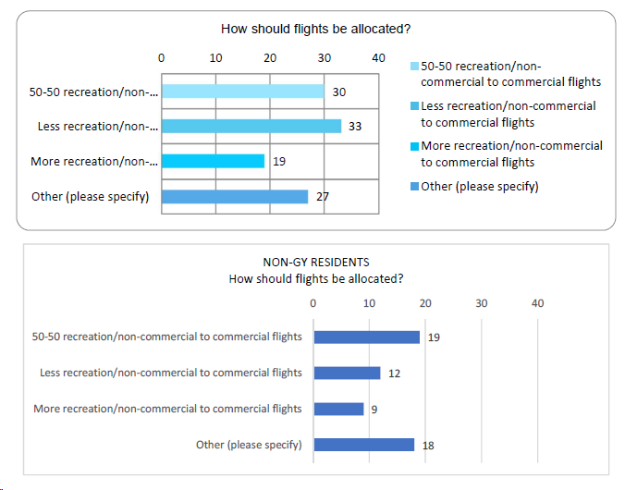
The crux of the plan going forward is how should flights be allocated. The survey options (above) if residents are included, show that 50/50 has scored high. The context around these answers is that there is a commercial benefit to businesses who have staff based in Glenorchy. Overall, there is not a hard and fast preference. There was an even spread of respondents and responses.

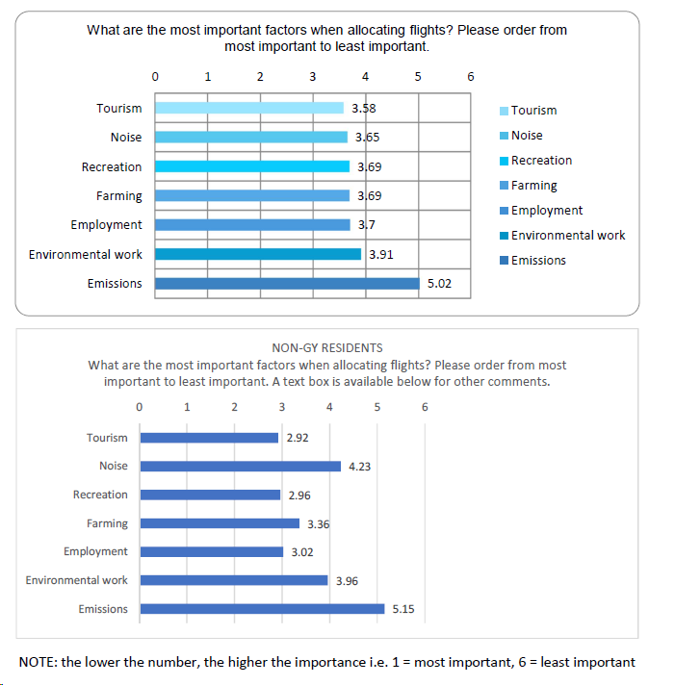

Emissions were least important for non Glenorchy residents. Tourism, recreation and employment scored high. Overall, there was an even spread.
From a council perspective, we need to consider council policies like the CBP and the DMP, and the Environment court decision around noise. Parameters are dictated by the court decision and by the council prerogative. The RMP informs the Court’s decision. So, this is not locked in, if the RMP changes, the decision could change. But there has been a lot of evidence fed into the RMP to support this as it is.

ACTION: Roz and Jeannie to look into the submissions and understand the demographic of the respondees – may be useful to split out in future responses those who have an aviation background/aircraft. For the Employment and environmental innovation question, look into aviation of non-Glenorchy residents – context that is useful that was not part of the previous plan.

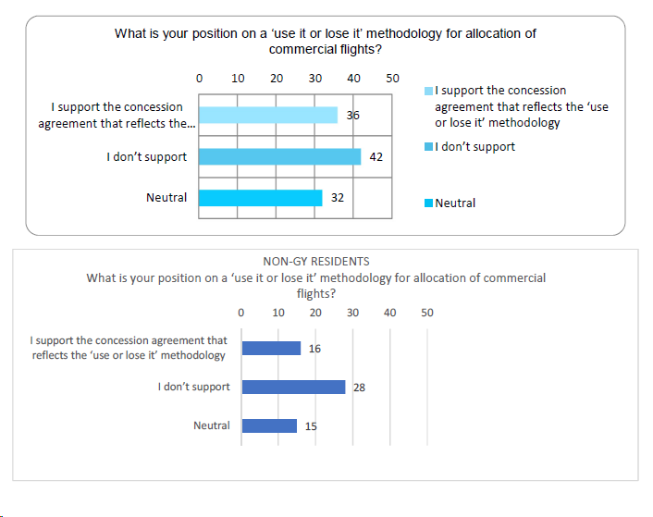

Position on use it or lose it methodology was that there was a reasonable amount of support, particularly from residents and those involved with aviation that are residents. This could be a good indication to keep the use it or lose it policy. In terms of commercial operation, if they can’t make it profitable, then makes it harder to sustain in Glenorchy. If flights have not been used, then they should go back in the pool.
EndZone will move to Wānaka. If they held flights and moved, then it would be fair to lose them.
NG explains that companies: lose it, share it or lose it, not just use it or lose it.
Previous term of use was that companies are allowed the same amount of allocation as the previous year, and if they meet their allocation, they could request to council some of the unallocated landings.

RMP should be under constant review to cover when there may be changes in demand.

Spike days on good weather in summer which bumps up against noise limits.

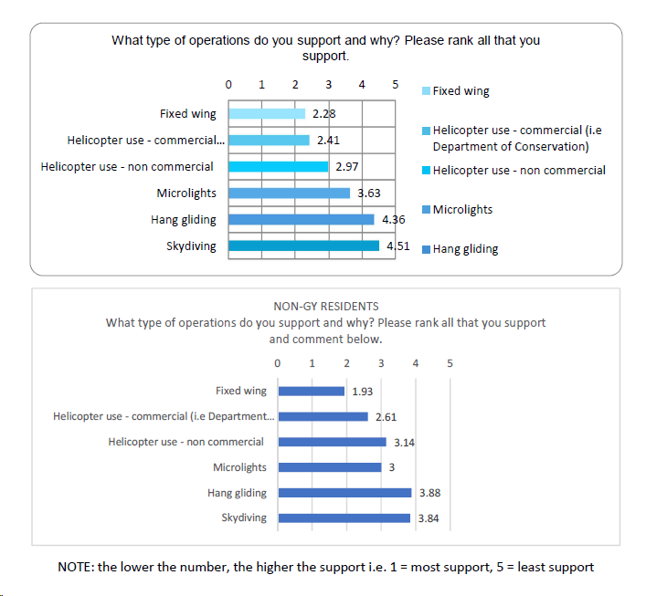
The types of operations supported would have been interesting if we had pulled the Glenorchy resident data. Results showed that we are relatively even across all options. Surprisingly, fixed wing aircraft had the highest approval. Would be good to understand why. This may be as these aircraft are used for rescue, training etc.
Question on ranking support: how was this calculated? Answer: this would be an average number. Therefore, there would have been a statistical issue for those that chose zero. ACTION: Need to look into this further. Actual numbers versus averages. – Jeanie and Roz action.
This is not a surprising reflection on what we hear, could include bold policies around no hang-gliding etc. Would be good to hear feedback.

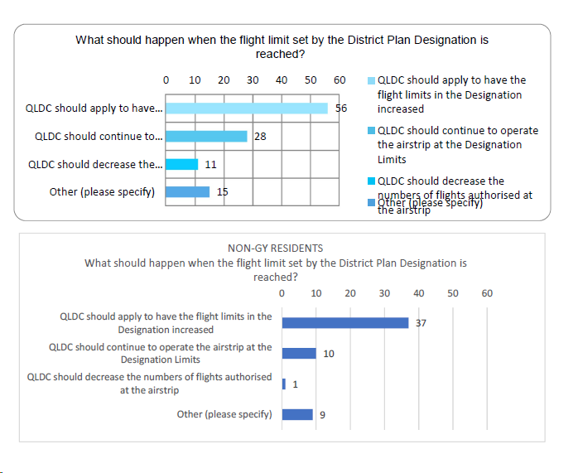
Non-Glenorchy residents want to increase the flight limit whereas Glenorchy residents want to maintain the number of flights. The policy would be around maintaining flights. More context and processes around limiting the number of flights and how they are allocated that was not seen in the 2016 policies. Situation has changed drastically with pool of flights with NZone moving out. Potentially not feasible for them anymore. They have 12 flights a year, and around one a month for training. No one has heard from EndZone or know what they are up to. Infrastructure is still there. Up to Council leases.
ACTION: QLDC to check if they have changed or are renewing their lease. – Jeannie/Roz/Quintin?

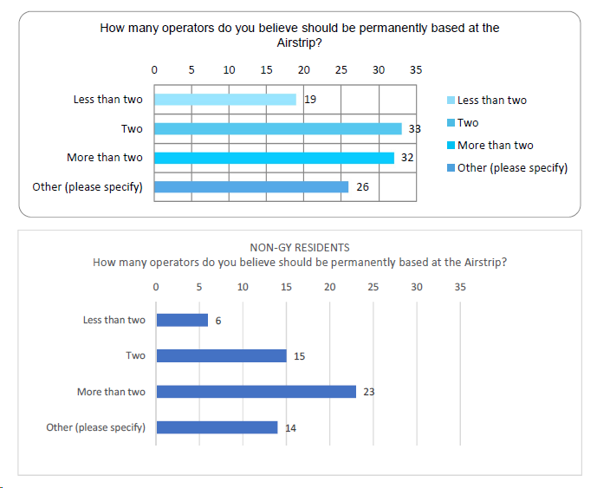
Non-residents wanted many permanent operators at the airstrip whereas residents want 2 or fewer. When it is about benefit to the community. Given landing numbers for the noise limit, too many operators would be detrimental to operations and profitability. If only one operator, do we try to encourage a second one? We could state that a second operator would have to bring benefit to the community. Could include a set of criteria. The viability of this will depend on the wording of the policy and the benefit to the community.

As for Skydiving or particularly disruptive activities; non-residents are happy with these activities, but residents are not.

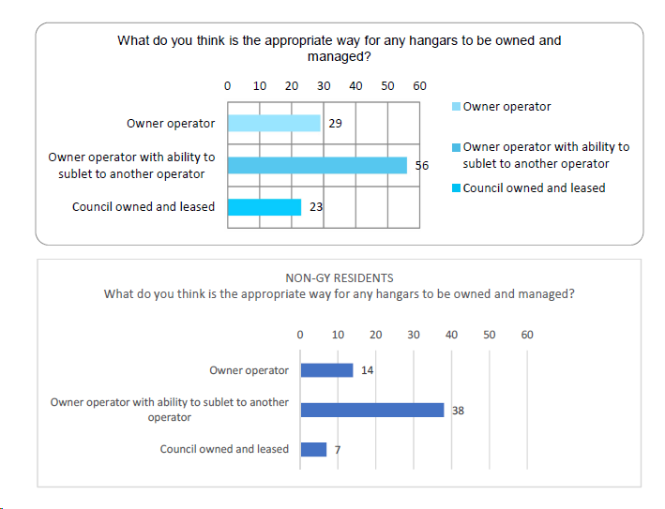
Residents and non-residents prefer joint ownership and management between council and operator. At the moment, these are mostly Council owned and managed, but this is the least favourable option. Did anyone ask Council? No formal submission, we would prefer a ground lease with the building maintained by the owner. Most flexibility for most use may be the best option. Conditions of subletting would need to be specified in the policy.

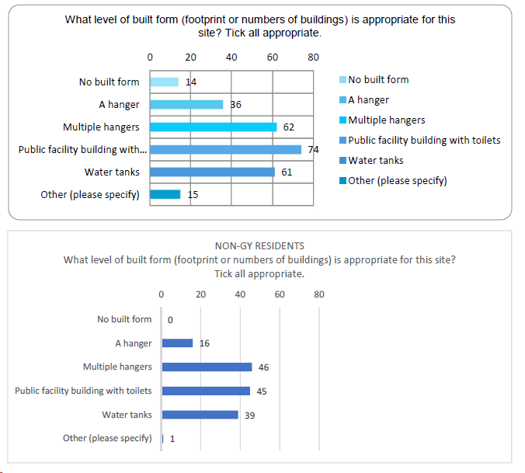
Other in this question included– none, café, fuel availability. The “Other” options have mostly been provided by Glenorchy residents.
There is an appetite for change and QLDC is considering funding. However, if owner-operated, this cost would be covered by them. (General Discussion)

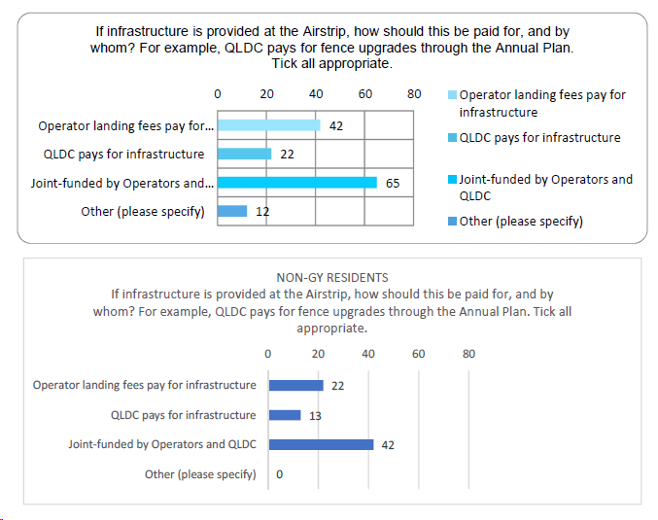
Question on how we pay for the infrastructure with Operator landing fees as the second favourite. Council paying is the least favourable option. Joint funded is favoured. However, QLDC now has no money due to changes in the LTP. Direction this could go with the policy, currently landing fees cover the QAC cost to manage/maintain the site. Piece of work for QLDC to look at incomings and outgoings before writing the policies. For anything to be covered by QLDC the landing fees would have to go up astronomically. If there is a drive for public infrastructure like toilets, then this gives operators the ability to provide the facilities if desired. (General Discussion)The policy would need to take this into account.

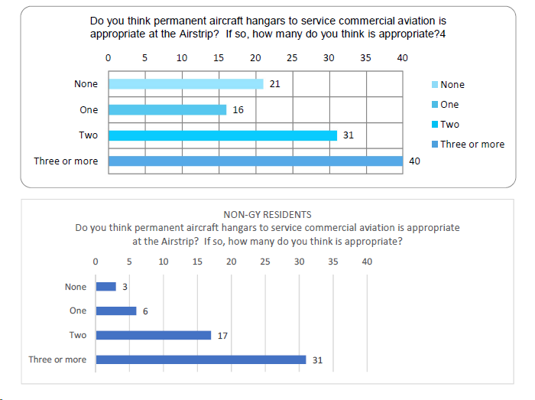
Certainty is needed for those that are operating and building the infrastructure. We need to ensure that those who put up hangars, that if they can’t be sublet, then they need to have flights. The Hangar policy and Sublet policy need to work together.
Glenorchy residents/Wyuna don’t want hangars, so if we allow Hangars then we would need justification. 2 operators with caveats and 2 hangars maximum.

The process is to go through to prove that this is beneficial to the local community. Need to ensure it does work for Glenorchy.
Survey gives direction, but feedback and consenting would also need to be considered.
In terms of the rural community, if it is anticipated in an RMP it could be non-notified. Could be enabling compared to the Wānaka Water sports facility which was more drawn out and expensive. Could smooth the way for the appropriate operator in the appropriate way.

With a short lease, it is hard to invest in infrastructure –therefore the tenure of lease needs to be considered.(General Discussion)

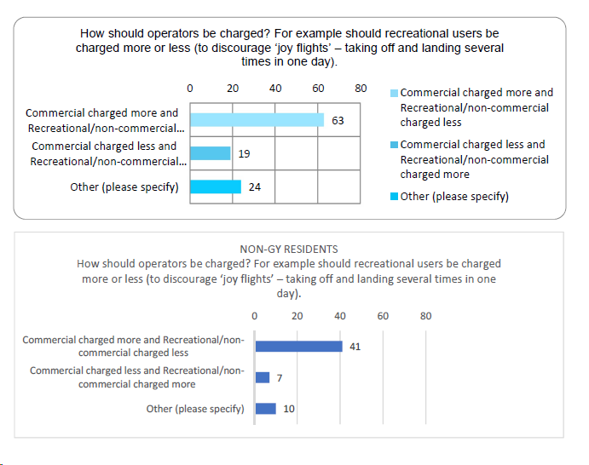
Residents and non residents would prefer if commercial flights were charged more. However, there will still be noise, no matter the aircraft, so what we use to differentiate? QAC are all the same. Difference would be on the weight. Weight causes more damage to the runway, so it has a higher cost. We do get that data so we need to think about how we put that in the plan. The dollar value would not be in the plan, because that makes it hard to change. Work on current market value – all the same by weight.

Is there a difference between fixed wing and heli? Heli maintains their own areas. Fixed wings requires more maintenance with a longer runway.
Question: Are recreational aircraft more likely to be fixed wing? Answer: More likely.
Same across board if that is industry standard.

How are the recreational people represented on the committee? I assume it is just us? That is a good point but they are only a fraction of the users. Ufly is a private company who sets up the recreational itinerary. We could be in touch with them specifically. Recreational comes under Nick and James, for fixed wing and heli. Not on the committee, but make sure they have the opportunity to submit. (General Discussion)
ACTION: for Jeannie to consider following up/getting information from Nick and James)/Ufly. Aeroclubs make be on the Qmug? Email list to contact recreational flights.

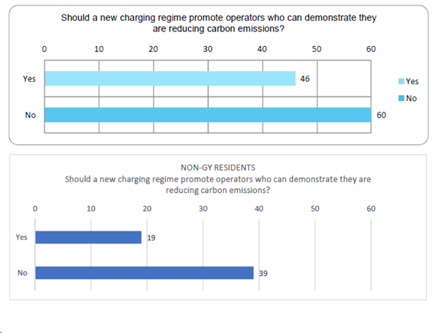
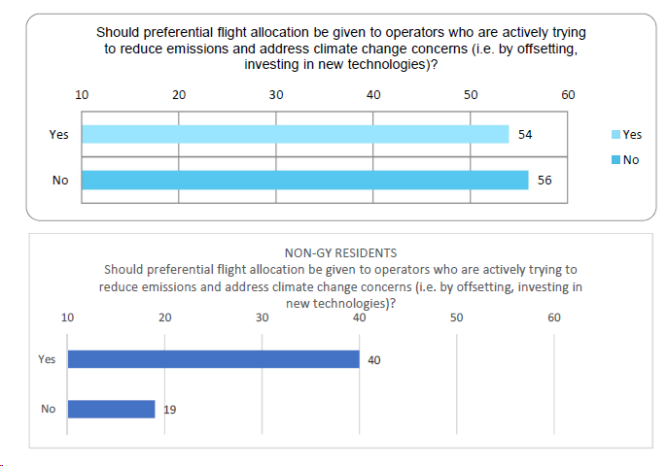

Preference given to those trying to reduce emissions would be easy to write in as a policy. Charging regime for those demonstrating emissions reduction – could this be signalled/spoken to for consideration in future iterations?

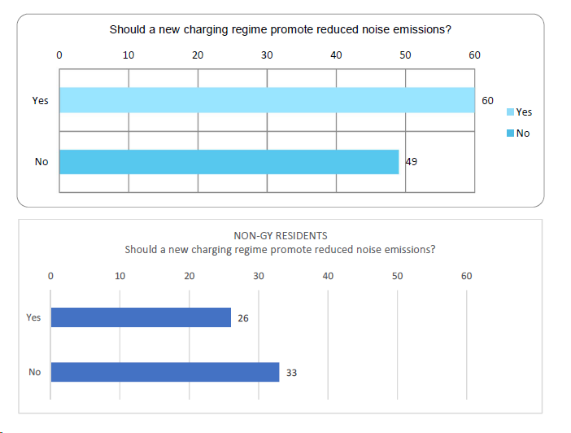
Residents would like a charging regime to reduce noise. This is a 50/50 from non-residents.
Residents don’t want increased noise, but also want more of a contribution to the infrastructure.
Operators are trying to reduce noise and emissions; however, bigger operators have an advantage – they could do fewer larger flights. The main objective would be around considerations.

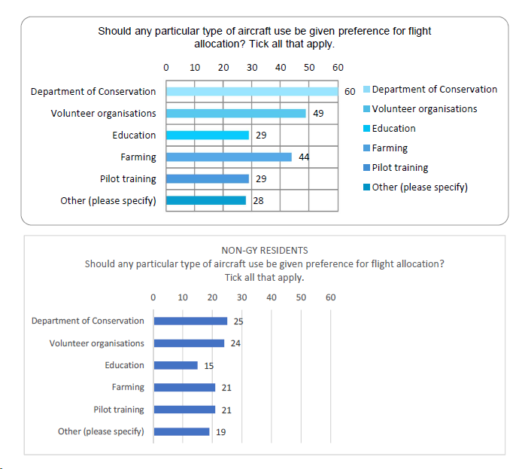

The locals rated volunteer organisations highly for “any particular aircraft given preference”. This was not in the last plan. So, this could be tied into considerations for the plan.

ITEM 7: General Business
A couple things from the GCA that John sent through. RMP ignoring adaptation piece. Consideration around going through adaptation. Rationale for not expanding the number of flights at this point.

Do we need to mention the possibility of the dispersal field? No money in the draft LTP to do this. Important part of Glenorchy land settlement, airstrip required for emergency flights. We are looking at a 5–10-year plan not a 30 year plan. We don’t want to lock in a dispersal field but don’t want to preclude it either.

ACTION: QLDC can we run past the policy team looking at the CBP and the DMP. Bill’s Team and Michelle/Peter.

ITEM 5: Complaints (QAC/QLDC)

One from the usual source around some activity beyond 8pm. Records show some just after 8pm ~8:15pm just before Christmas. Could have been Nick but could have been Blanket Bay sunset. Need to look into this and pull the information so we can respond to the complaint and let them know that it was Blanket Bay that operates under a separate plan/restrictions.
ACTION: for Jeannie to follow up with Nick/monitoring and enforcement)

To add to the meeting next time/agenda items:
Earmark “Airstrip Operations Update (QAC)” for the next agenda, as didn’t have time to go through this now.

