Appendix A

Units A, B, C & D at 8 Caernarvon St, Arrowtown (Indicative area only)
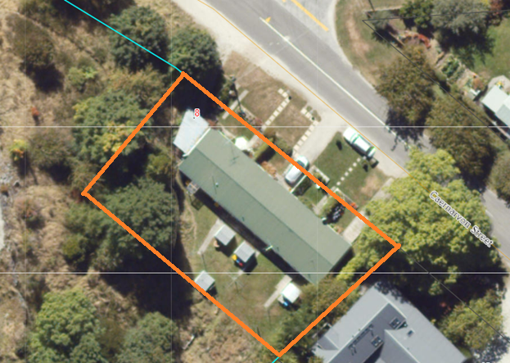

Units 1, 2, 3 & 4 at 45 McDougall St, Wanaka
