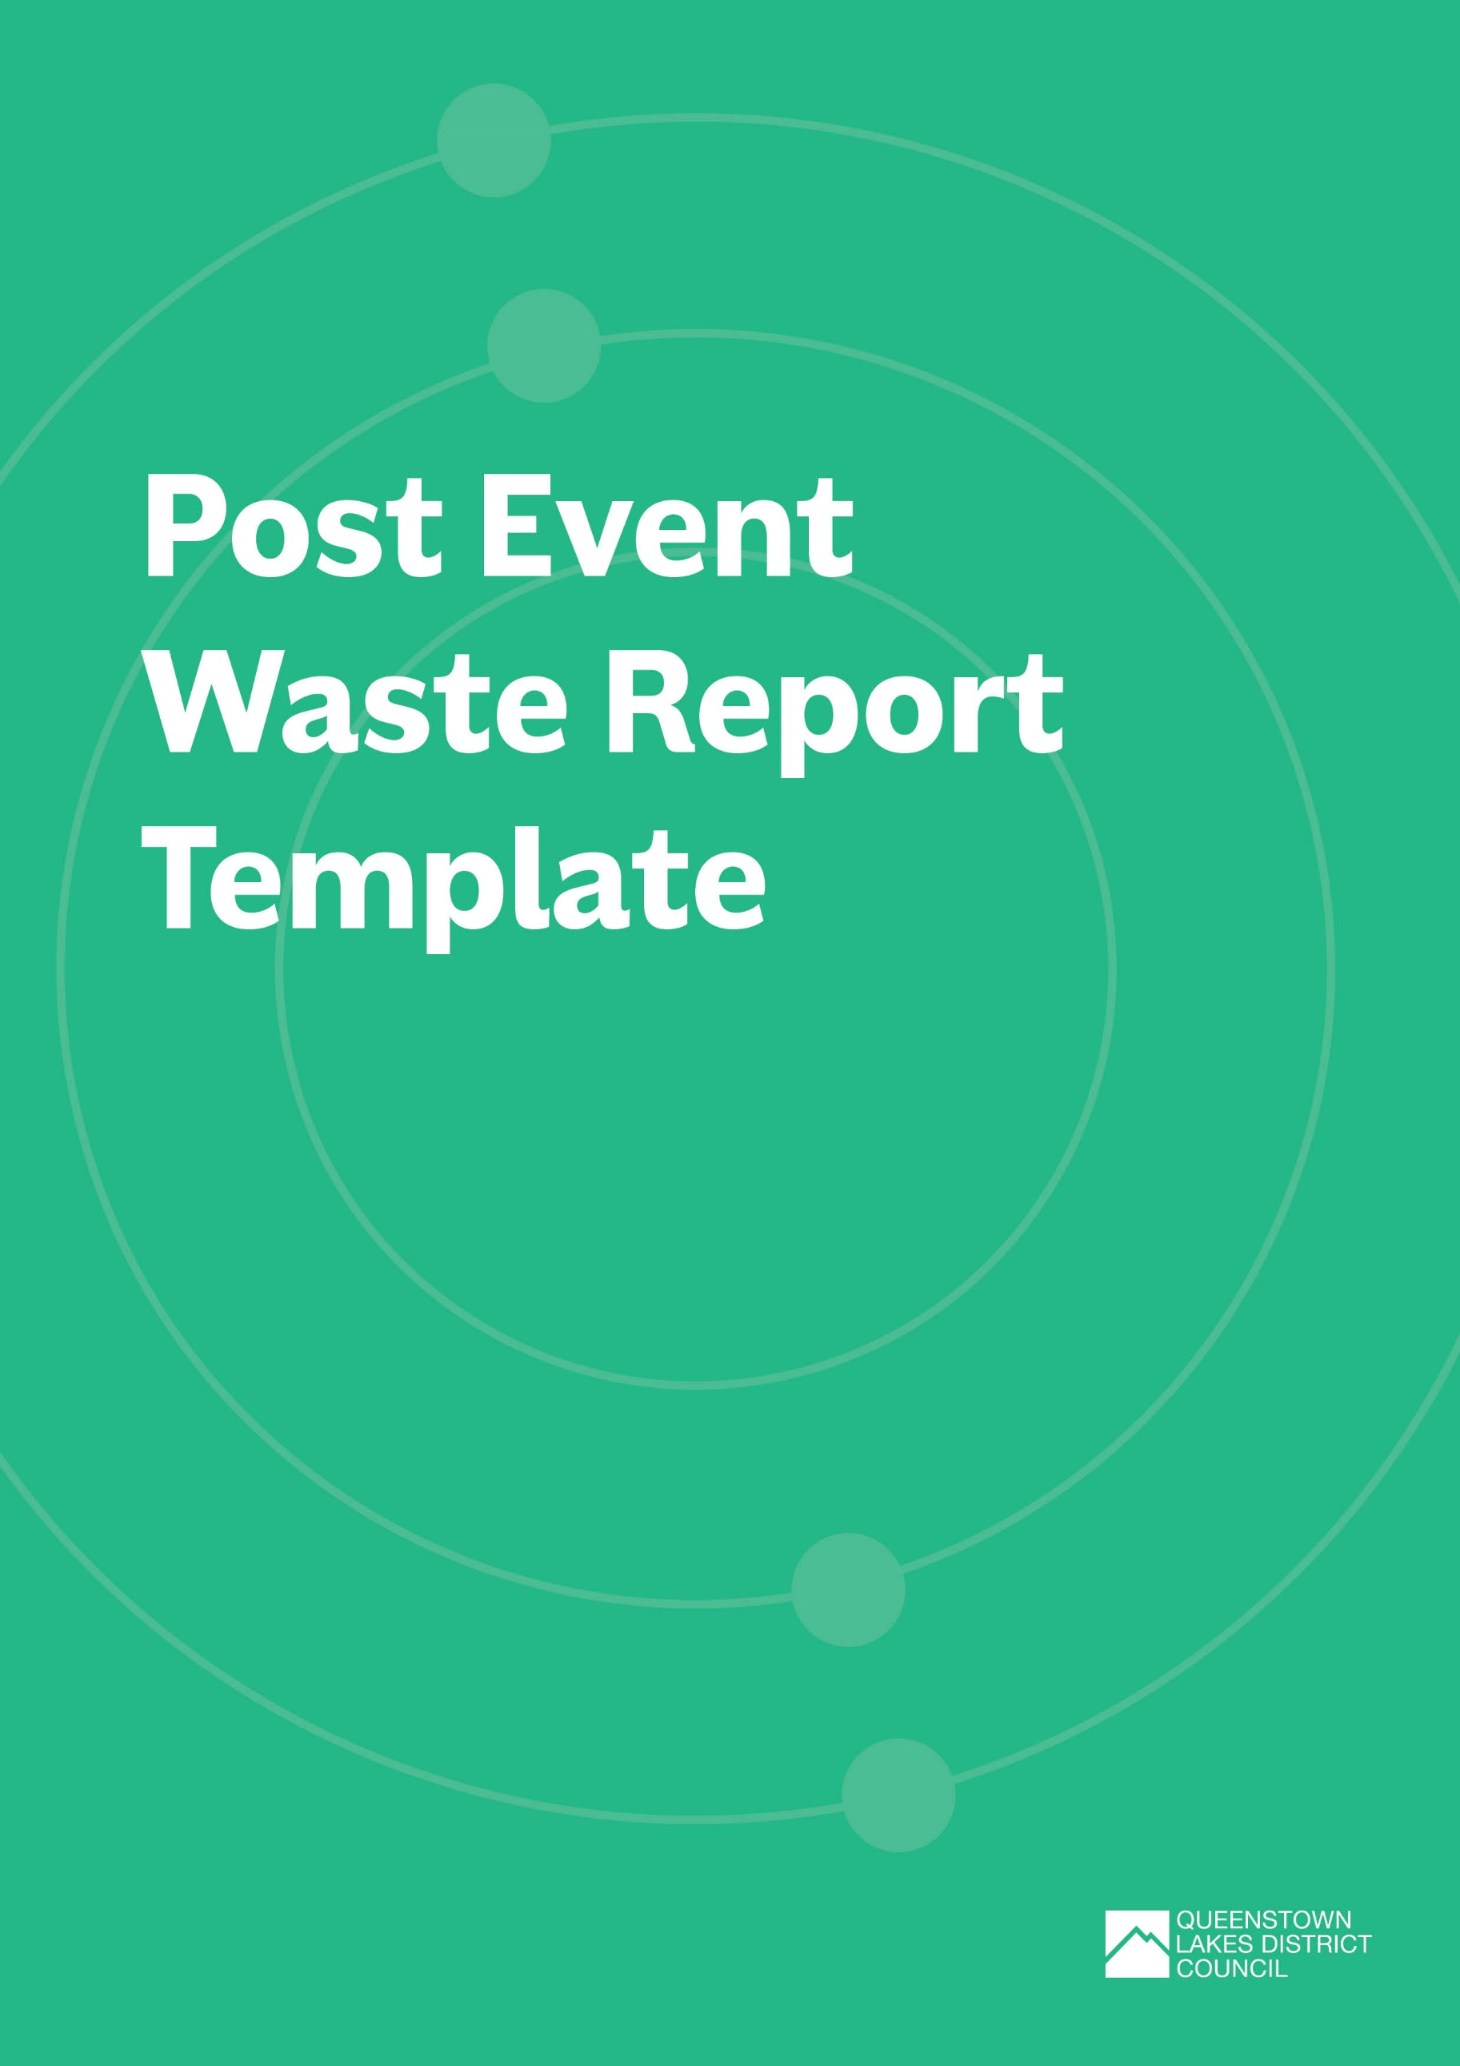

Post Event Waste Report Template
Use this template to document and analyse waste generated during your event, evaluate the effectiveness of your waste minimisation initiatives, and identify opportunities for improvement in future events.
The template is broken into the following sections:
- Event overview
- Waste and materials stream data
- Waste diversion and targets
- Infrastructure and layout feedback
- Stakeholder communication and engagement feedback
- Vendor and supplier participation
- Cost and resource allocation
- Additional feedback

How to use this template:
Complete each section below. You can add or remove rows in the tables as needed. We’ve provided some prompts and examples in greyed out text, just delete these as you work through your plan.
Please submit your completed plan and any supporting documents via email to our QLDC Waste Team within 28 days of your event: zerowaste@qldc.govt.nz

Event Overview
EVENT DETAILS
Event title: | Title of event/ official name of the event that will be referred to on any applications
Type of event: | E.g.:  - Arts / Cultural (Outdoor Exhibition or Performances)  - Entertainment (Music Festival, Circus, Concert)  - Community Event (School Fair / Gala Day, Fundraiser)  - Sports (Marathon, Cycle Race, Water Sports)  - Market (Craft Market, Food Market, Farmers Market)
Name of organisation delivering the event: | Lead organisation hosting the event
Location (attach or insert map if possible): | Venue name, location and description
Date(s) of event: | Pack in:
 | Event start:
 | Event finish:
 | Pack out:
Total number of attendees:
Number of food and beverage vendors:
Number of marketplace/ merchandise vendors:

Key contacts
Note down the details of the key people responsible for developing your Post Event Waste Report.
ROLE | ORGANISATION | PHONE | EMAIL

WASTE and materials stream data
Quantify your waste streams including general waste, mixed recycling, glass, organics, etc. If you used one, your waste collection contractor should be able to supply this information.
MATERIAL/WASTE STREAM | AMOUNT (KG) | COLLECTION CONTRACTOR (IF APPLICABLE) |  |  | WASTE/MATERIAL PROCESSING FACILITY
E.g., cardboard |  | E.g., Wastebusters |  |  | E.g., Wastebusters
E.g., mixed recycling |  | E.g., Smart Environmental |  |  | E.g., Wakatipu Recycling Centre
E.g., glass |  | E.g., Wastebusters |  |  | E.g., Wastebusters
E.g., food scraps |  | E.g., AllWaste |  |  | E.g., Central Wormworx
E.g., used cooking oil |  | E.g., Wastebusters |  |  | E.g., Flower Power
E.g.; general waste/rubbish |  | E.g., AllWaste |  |  | E.g., Frankton Transfer Station
Was any additional waste created at your event, which you weren't expecting? |  |  | ☐ | Yes
 |  |  | ☐ | No
If yes, please provide further details.
Did you or your waste contractor do a waste audit or post event waste sort? |  |  | ☐ | Yes
 |  |  | ☐ | No
Please provide further details.
Were there contamination issues with recycling or organic (compost) waste streams? |  |  | ☐ | Yes
 |  |  | ☐ | No
Please provide further details.

WASTE Diversion and targets
Identify whether you achieved your targets, including your diversion rate.
Total waste/material generated (kg)
Total waste/material diverted (kg)
Actual diversion rate (%)*
Diversion rate target (%)
Did you meet your diversion rate target (%) | ☐ | Yes
 | ☐ | No
If you did not meet your target, explain why.
*Diversion rate is calculated by dividing the weight of diverted waste (e.g., your total recyclables) only by the weight of all waste generated. Multiply the amount by 100 to get your percentage (%).

TARGET | DID YOU ACHIEVE YOUR TARGET? |  | IF YOU DID NOT ACHIEVE YOUR TARGET, EXPLAIN WHY.
E.g., Less than 5% contamination in the mixed recycling and glass bins for year 2 of the event. | ☐ | Yes
 | ☐ | No
E.g., 90% reduction in the amount of food waste disposed of in the landfill bin during the event in its first year. | ☐ | Yes
 | ☐ | No
E.g., No single use coffee cups used throughout event. | ☐ | Yes
 | ☐ | No
 | ☐ | Yes
 | ☐ | No
 | ☐ | Yes
 | ☐ | No

What strategies or initiatives were particularly effective in achieving waste reduction goals?

Where there any waste reduction or reuse initiatives that did not work well? Please provide detail.

Infrastructure and layout Feedback
Consider the effectiveness of your waste and reuse infrastructure, layout, and logistics to help you to make informed decisions for future events. Note, you will need to gather feedback from your service providers to complete this section.
Waste Infrastructure and Signage: | E.g.  - How effective were your front- and back-of-house waste stations in encouraging proper disposal of recyclables, compostables, and waste?  - Were there adequate front- and back-of-house waste stations in place to service the event?  - What were the notable successes in waste infrastructure during the event?  - Were there any unexpected challenges that need to be addressed for future events?  - Outline what signage you used to promote the use of waste stations, reuse infrastructure, and other waste diversion efforts?  - Were there any areas where additional signage was needed?  - Did attendees express any confusion or difficulties in following the signage?  - Were there any suggestions for improvements in terms of messaging, colour, size, or aesthetics?  - Did the signage encourage active participation in waste reduction initiatives?
Reuse Infrastructure: | E.g.  - Outline what reuse infrastructure you implemented for your event.  - What strategies were employed to promote and educate participants about the reuse options?  - How well did the logistics of the reuse infrastructure work? Were there any bottlenecks or inefficiencies?  - Did you collect data to quantify the reduction in single-use items due to the reuse initiatives? If so, how and what impact did the reuse infrastructure have on overall waste reduction?  - Were there any challenges or barriers identified in promoting reuse infrastructure?  - Were there any positive or negative comments regarding reuse infrastructure?  - What improvements or modifications could enhance the effectiveness of the reuse infrastructure?
Logistics: | E.g.  - Were there any logistical challenges with waste collection, sorting or disposal?  - Were there any issues with the collection frequency and efficiency of emptying bins?  - How was data on waste and recycling volumes collected?  - Were any technological solutions employed for waste tracking or monitoring?
Staffing: | E.g.  - Were there dedicated personnel overseeing waste management during the event?  - Did you have enough staff or volunteers to implement your Event WMMP?  - Were the waste staff or volunteers trained in advance of the event?
Layout Effectiveness: | E.g.  - Did you make any changes to the site layout map developed as part of your event WMMP?  - How did the layout of your waste and reuse infrastructure contribute to or hinder the overall waste minimisation and management initiatives?  - Based on observations or any feedback received, what specific changes or improvements should be considered for the layout of your waste and reuse infrastructure at future events?

Stakeholder Communication and ENGAGEMENT FEEDBACK
Consider the effectiveness of your communication and engagement efforts to help you to make informed decisions for future events.
How were the key messages about waste and reuse infrastructure effectively communicated to stakeholders (e.g. vendors, entertainment, volunteers, event goers)?
How did you collect input from stakeholders on waste and reuse initiatives? How well did it work?
To what extent were stakeholders aware of the waste and reuse infrastructure initiatives?
Which communication channels were most successful in reaching stakeholders?
Were there any barriers or challenges in effectively communicating about waste and reuse infrastructure?
Were there any observable changes in behaviour or attitudes of stakeholders as a result of communication about waste and reuse initiatives?
Based on stakeholder feedback, what opportunities were identified for improvements to communications about waste and reuse infrastructure at future events?

Vendor and Supplier Participation: | Did you capture feedback from vendors and suppliers? How?
 | Were vendors and suppliers informed about the event's waste minimisation goals in advance?
 | Were vendors and suppliers provided with clear guidelines on waste separation and disposal?
 | Did vendors and suppliers actively participate in waste reduction efforts, such as minimising single-use items?
 | How effective were vendors and suppliers in sorting and separating waste?
 | Did you undertake vendor assessments?
 | Were there incentives for vendors or suppliers engaged with waste minimisation initiatives?
 | Were there any challenges or barriers that vendors faced in implementing waste and reuse initiatives?
 | Did vendors or suppliers encounter any issues with waste management that could be addressed with additional support or resources?
 | How could vendor and supplier engagement be improved in future events?

Cost and Resource Allocation
How did the allocated budget align with the actual costs of implementing waste and reuse infrastructure?
Were there any unexpected costs or resource requirements?
Can the cost-effectiveness of waste and reuse initiatives be improved in future events?

Additional support
For further information or assistance with your post event waste report template, please contact the Queenstown Lakes District Council at zerowaste@qldc.govt.nz

